3.1 DNA profiling
Nowadays, DNA plays a very powerful role in forensics. The use of DNA in crime scene investigations has grown rapidly over the past years. What exactly is DNA and how is it used in forensics?

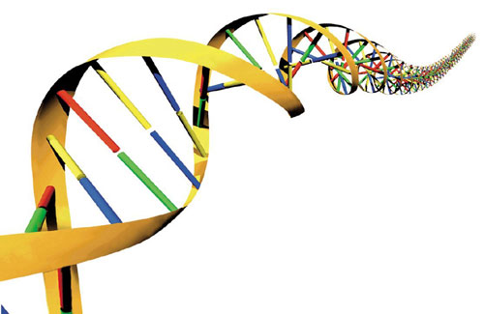

3.1.1 What is DNA?

There are a lot of sources on DNA to find on the internet. An important source for information is a guide developed by the European Initiative for Biotechnology Education. Your teacher can give you (part of) the guide that this organization has developed. You can also download it yourself at
http://www.ipn.uni-kiel.de/eibe/UNIT02EN.PDF

- Find in literature (the given source but also other sources) information about DNA
- Write an essay (400 – 500 words)on this. Be sure to address the following questions:
  - What are short tandem repeats?
  - What is a ‘locus’?
  - How can DNA be damaged?
  - How can DNA be multiplied?

