3.6 The Bertolin system

Before fingerprints and DNA were used to identify people, the anthropometric measurement system was sometimes used. This system was developed by Alphonse Bertillon (1853–1914), the son of a medical professor. In his system Bertolin identifies some characteristics of the human body and uses these to make an identification system. Below you see an example of the measurements to take.

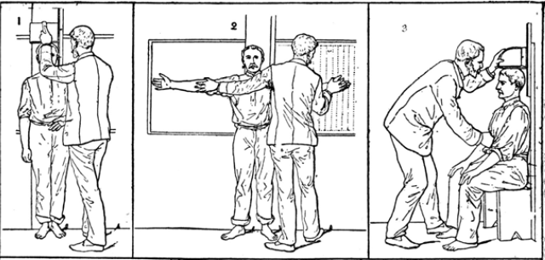

Credit: Alphonse Bertillon, Signaletic instructions including the theory and practice of anthropometrical identification ,
Chicago, 1896. National Library of Medicine

- Get the complete instruction and data sheet from your teacher
- Write down your measurements in the data sheet
- Give your data sheet to your teacher and collect a new data sheet
- Identify your classmate using the data sheet given to you by your teacher

