3.4 Identifying with use of DNA

3.4.1. To check once again the process of DNA-identification, you can play this online game.

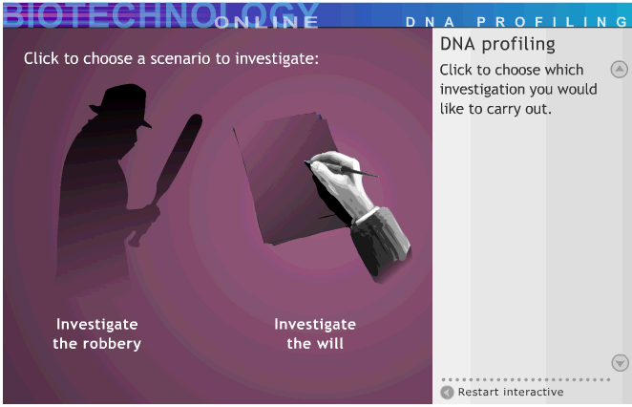

http://www.biotechnologyonline.gov.au/popups/int_dnaprofiling.html

In this game you can choose to investigate a will or to investigate a robbery.

- Play the game and try to solve both cases.
- Explain in your own words why you have to turn on the electric current in this game.
- Explain in your own words what the vertical stripes in the picture below mean.

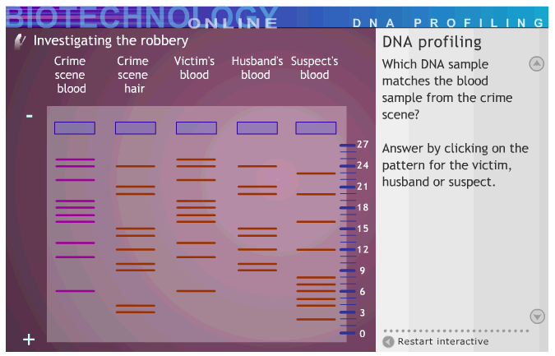

- Did you succeed to solve the robbery? Explain what were the difficult steps in this research.
- Did you succeed to solve the problem with the will? Explain what were the difficult steps in this research.

3.4.2. Identifying with the use of DNA in real life

It is difficult to do your own DNA analysis. Materials to do this experiment are very expensive, for schools it is not possible to buy reliable DNA-kits. However, in many countries there are companies that can support schools. For example with excursions, visiting lecturer or making equipment available. You will hear from your teacher what the possibilities are for your situation.

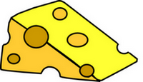
3.4.3 Who ate the cheese?
A basic activity where you solve a crime by investigating DNA traces as they were found on a piece of cheese. With paper and scissors you do the same experiments that are done in real life. You can demonstrate that you really understand the properties of DNA identification by identifying the criminal and by explaining the similarities and differences between this experiment and real life.

See http://www.biologycorner.com/worksheets/who_ate_the_cheese.html

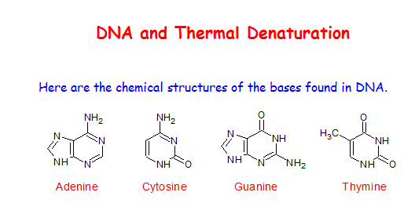
3.4.4 DNA-pairing

Investigate the properties of DNA denaturation with the use of this excel file.

See http://aa5.nl/snd3E

