4. Measuring on crime-scene pictures

A crime scene is often meticulously recorded by pictures.
- Why would it be so important to record the whole crime scene in pictures?

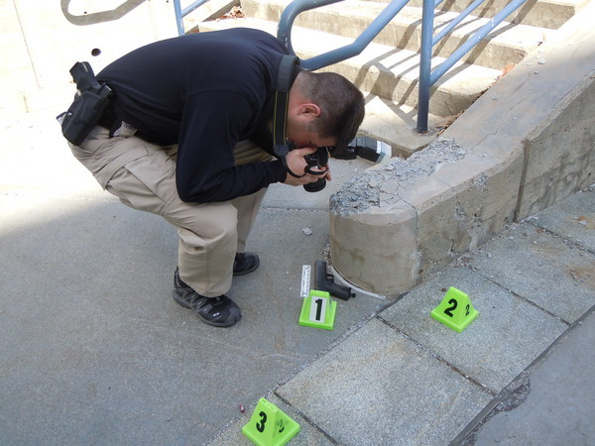

4.1 Introduction
In the picture above, you see a police officer in training taking a picture from a fake crime scene.
- Look at the picture above and describe the items that might be important in this scene.
- To the left of the pistol is a ruler. Do you think this is also an object from the crime? Explain your answer.
- Why do you think does the police officer take the picture from right above?
- If you need to know the distance between the objects from the picture can you tell for sure which distance between the three marked objects is largest and which is smallest? 1-2, 2-3 and 1-3? Why or why not?
- Can you say for sure that the distance of the photographer’s right foot to object 2 is larger than to object 3? Why or why not?
- What can you say about the shape of the tile on which object ‘2’ is placed? Compare the shape on the picture with the real shape you know from every-day life. Explain the difference.

4.2 Measuring distances on pictures

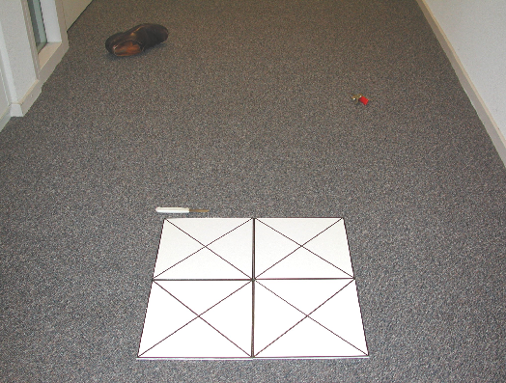
As a forensic scientist you cannot always walk through the crime scene, because you may destroy evidence. Or you are called in at the moment the crime scene is already cleared for a long time. Then the pictures may be the only way to know what the crime scene did look like. If you need to collect information e.g. about distances between objects you have only the picture at your disposal. But, it is usually impossible that an overview picture of a crime scene is taken directly from above. Therefore there is perspective distortion.
- Explain in your own words what you think is meant with perspective distortion? If you do not know, find some information about perspective distortion.
- What evidence can you give that there is perspective distortion in the above picture?
The pictures of a crime scene will be analyzed. An important thing to do is determining distances between different objects.
- Give some reasons why it can be important for you as a forensic scientist to know the real distance between objects in a crime scene
- Find out what is meant by perspective deformation and write a summary in which is explained how this can occur.
Look at the photograph above from a crime scene. We see a shoe, some keys (with a red label) and a knife (with a white handle). There are also four square tiles placed on the scene to use as a reference. These tiles are 25 cm wide and 25 cm high.

- Estimate from the picture the distances between:
  - Keys – shoe
  - Keys – knife
  - Knife – shoe
- Explain how you can see that the picture has a perspective deformation.
- Which two items are closest to each other?
- Use the software package Coach to determine the distance between the three objects.
- Start Coach activity ‘Measuring on crime scene pictures – Instruction’. Follow the included instructions.
- After this activity, there are two more activities in which you can measure distances on pictures:
  - ‘Measuring on crime scene pictures 2’ in which you will measure the distance between the objects on the picture shown in 4.1 and
  - ‘Measuring on crime scene pictures 3’ in which you measure stride length and come to an estimation of the suspect’s length and possibly some other body features.

