Activity 2.2B: Station 2: Invisible Holes

Worksheet 2:

The transparent membranes, which appear in the pictures, are used to wrap presents, flowers, sweets and all sorts of foodstuffs (fruit, vegetables, meat, cheese etc) usually in order to preserve them and keep them fresh.

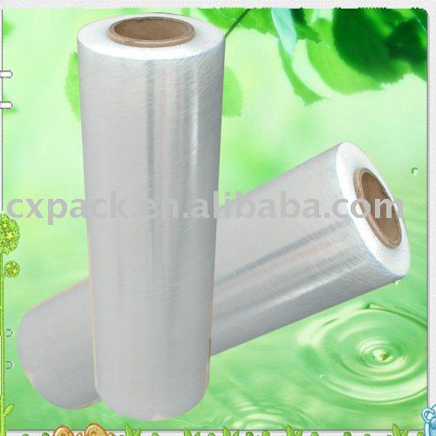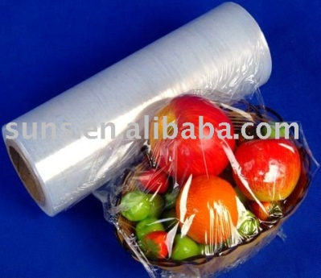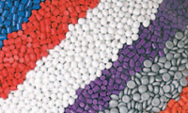

These membranes are made of polymers, such as, polyethene, polypropene, PVC, polycellulose etc.

The factory “PLASTICO” is advertising that the transparent membranes of the series ‘’FoodFilms,’’ which it produces and sells in the market, are suitable for wrapping foodstuffs, because they are not penetrated by micro-organisms and chemical substances.

Your teacher has provided you with two of these membranes and asks you to investigate whether the company’s advertisment is true.

Prediction: Before proceeding to carry out the experiment examine the two membranes and make your own prediction and exchange opinions with the members of your group:

Are the two membranes (or one of the two) permeable to chemical substances or not? On what do you base your hypothesis?
_________________________________________________________________
_________________________________________________________________

Discuss with your group and carry out experiment 2.

Experiment 2 - Procedure

- To carry out the experiment, you have two transparent membranes
(A and B) and an iodine solution available.
- Place two 150 mL beakers in a row and add 120 mL water into each.
- In two test tubes (A and B), add the same quantity of iodine solution (to about a 3cm height)
- With a piece of membrane, which you should previously dampen with water, close the opening of tube A by wrapping it on the tube’s external surface and securing it tightly using a rubber band.
- After that, secure the tube upside down on a stand with its opening inside the water, as shown in the figure below.

Iodine solution

Water

- In the same way, work with membrane B.
If one of the membranes is permeable to the iodine solution, what observations do you predict in the beaker with the water and why?
_____________________________________________________________________________________
_____________________________________________________________________________________
_____________________________________________________________________________________
- Leave the two solutions to stand for 7-8 minutes attentively observing all the changes in the two beakers.
Discuss with your group and write down the results and the interpretation of the results (questions 9,10,11,12,13,14,15)

Results

- Write down your observations of the two beakers:
Beaker Α: _______________________________________________________
Beaker Β: _______________________________________________________

Interpretation of Results

- What do you conclude from the above experiment? _______________________________________________________________
_______________________________________________________________
- Draw your observations of the two membranes in the figures below. Correct the size of the pores in each membrane if needed.

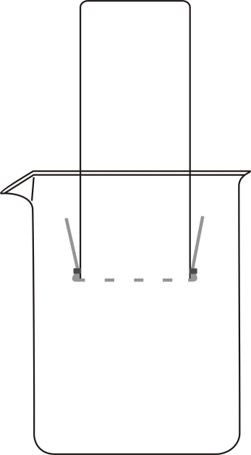
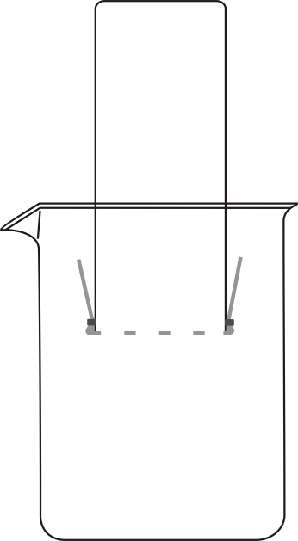

Α
Α Β
- Is the prediction you made in question 7 concerning the changes in the beakers with the water right or wrong? If there is a need, amend your explanation accordingly.
______________________________________________________________
______________________________________________________________

- Is the advertisment of the “PLASTICO” factory justified? Is the claim of the company that the ‘’FoodFilms’’ membranes are not permeable true or false?
______________________________________________________________
_______________________________________________________________
_______________________________________________________________
- Is your prediction concerning the membranes’ permeability correct or not?
_______________________________________________________________

- The factors (variables), which influence the experiment, are the following:
membrane (pores of the membrane), permeability, dissolved substance (size of its particles), liquid in the beaker, quantity of solution in the test tube.
Which of the above variables are:
a. Controlled variables (factors which I keep constant): __________________
___________________________________________________________
b. Independent variable (a factor which I can alter): ____________________
c. Dependent variable (a factor which I can measure/observe): ____________

Answer questions 15 and 16 individually

- Which one of the membranes would you use to wrap your sandwich? Support your answer. ______________________________________________________________
______________________________________________________________
______________________________________________________________
- If you used salt water instead of iodine solution in the above experiment, what would happen? Explain your answer. ______________________________________________________________
______________________________________________________________

Homework

- Which one of the membranes would you use to wrap flowers? Explain your choice. ______________________________________________________________
______________________________________________________________
______________________________________________________________

- Do you think that the particle (molecule) of iodine is larger than a cell of a
microorganism? ________________________________________________
Are there particles that are smaller than the particle of iodine? ___________
Are there particles that are larger than the particle of iodine? ____________

- Search the internet for more information on transparent membranes and mention their different uses. For every example, explain the relationship between the permeability of the membrane and its use.

