Activity 2.2C: Station 3: Membranes in Medicine

Work Sheet 3:

Artificial membranes are widely used today in medicine, for example, in artificial kidneys. As it is well-known, the kidneys are a basic organ of the human organism which, among other things, cleans (filters) the blood from toxic substances, which are secreted through urine. In order to deal with renal failure several different methods are used, including haemodialysis or as it is usually called “artificial kidneys.” Through a membrane, the useless (toxic) substances are removed from the blood, while, at the same time, the useful substances are retained.
The pictures below show such artificial membranes, which are used in haemodialysis.

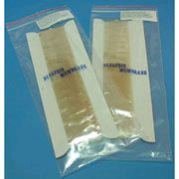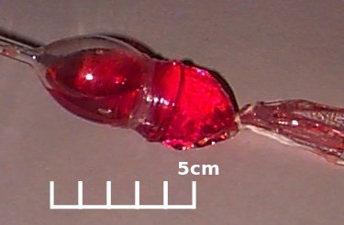

These membranes are made from various plastics and polymers.

Prediction:

Do you think that chemical substances can pass through a transparent membrane?

Before carrying out the experiment, discuss with your group and try to answer the question after handling the membrane which you are going to use.

Discuss in your group and carry out experiment 3.

Experiment 3 – Procedure

- In order to carry out the experiment, you have a transparent membrane available as well as two solutions:
  - iodine solution and
  - starch coloured with iodine.
- Place two 150 mL beakers in a row and add 120 mL of water in each.

- In two test tubes (A and B) add a solution of iodine to the first and a solution of starch to the second (about the same quantity, to a height of 3 cm).
- With a piece of membrane, which you should firstly dampen with water, close the opening of tube A by wrapping it on the tube’s external surface and securing it tightly using a rubber band.
- After that, secure the tube upside down on a stand with its opening inside the water as shown in the figure below.
- In the same way, set up test tube B.

coloured substance

water

- In case the two solutions, or one of them, passes through the membrane what changes do you predict you will observe in the beaker with the water and why?
_____________________________________________________________
______________________________________________________________
______________________________________________________________
- Leave the three solutions to stand for 7-8 minutes attentively observing all the changes in both beakers.
Discuss in your group and write down the results and the interpretation of the results (questions 9,10,11,12,13,14,15)

Results:

- Write down your observations of the two beakers:
Beaker Α: _______________________________________________________
Beaker Β: _______________________________________________________

Interpretation of Results:

- What do you conclude from the results of the two experiments?
____________________________________________________________________________________________________________________________

- Illustrate your observations of the two solutions in the figures below:

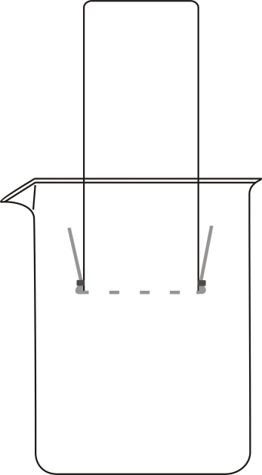
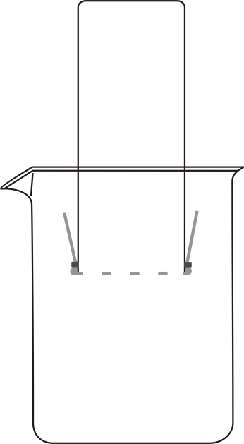

Α Β
- Is the prediction, you made in question 7, right or wrong? If necessary, revise your prediction.
______________________________________________________________
______________________________________________________________
- Which one of the two substances that you used (iodine, starch) has a larger size particle? On what do you base your answer? ______________________________________________________________
______________________________________________________________
- Compare the conclusion you have drawn after completing the experiment with the prediction which you made concerning the initial problem under investigation. Do you need to revise your prediction? Why?
______________________________________________________________
______________________________________________________________
______________________________________________________________
- The factors (variables) which influence this experiment are the following:
membrane (pores of the membrane), permeability, dissolved substance (size of its particles), liquid in the beaker, quantity of solution in the test tube.
Which of the above variables are:
a. Controlled variables (factors which I keep constant): _____________________________________________________________
b. Independent variable (a factor which I can alter): _______________________
c. Dependent variable (a factor which I can measure/observe): _______________

Answer questions 16 and 17 individually

- Why do you think the starch solution, which you used, has been previously coloured?
______________________________________________________________
______________________________________________________________

- Do you believe that hydrogen gas can pass through the membrane which you used in the previous experiment? On what do you base your opinion?
______________________________________________________________
______________________________________________________________
______________________________________________________________

Homework

- Why should the membrane be dampened before being applied to the opening of the test tube? ____________________________________________________________
______________________________________________________________

- It is well known that polymers (starch, cellulose, natural rubber, nylon, etc) comparatively have very large molecules. The image below presents the starch molecule coloured with iodine.
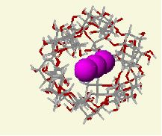
- Explain why the polymers have large molecules.
______________________________________________________________
______________________________________________________________

- Could the membrane that you examined be used in haemodialysis? On what do you base your answer?
______________________________________________________________
______________________________________________________________

- Search the internet and collect information concerning renal failure and haemodialysis or “artificial kidneys”.

