Activity 2.2E

Note: These activities should be performed by all groups and should be linked to the previous activities where the groups were rotating from one station to the other. Obviously, teachers should be randomly or otherwise divided into four groups and they should be instructed to perform all the activities concerning the four stations by moving from one station to the other.

A model for the separation of mixtures

Separation of mixtures, using sieves or filters, is frequently applied in all the human activities: at home (kitchen), in the industry, research and medicine.
There are plenty of sieves and filters available for different uses. In the Chemistry laboratory, we usually use filter papers for the separation of mixtures which consist of a liquid and un-dissolved solids.
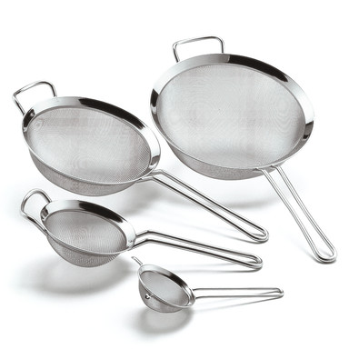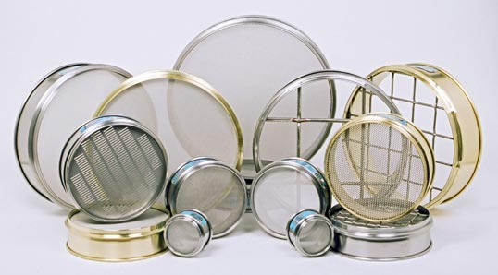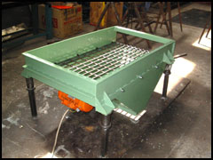

Procedure

Experiment a: Separating of mixtures with sieves – Separation model

At your work place you will find:
a. Sieve A (with bigger holes)
b. Sieve B (with smaller holes)

Furthermore you will find:
i. mixture A (Soya Beans – Tapioca)
ii. mixture B (Tapioca – Alfalfa Seeds)
iii. mixture C (Soya Beans – Tapioca - Alfalfa Seeds)

Discuss in your group and plan an appropriate procedure for separating the above mixtures in their components. Purpose of the activity is to compare the visible components of these mixtures with the invisible particles (molecules – ions) of chemical substances in mixtures.

Procedure Plan and carry out the following trials:

(a) Try to separate the three mixtures with sieve A.
(b) Try to separate the three mixtures with sieve B.
(c) Try to separate the three mixtures using both sieves A and B, if you consider this necessary.

Results

- Carefully record your observations

Interpretation of results

- Summarising your results, explain which sieve or sieves you used to separate each of the three mixtures?
Mixture A: ______________________________________________
Mixture B: ______________________________________________
Mixture C: ______________________________________________

- Which factors (variables) affect the trials you carried out?
____________________________________________________________
- Which factor did you decide to keep constant (controlled variable)?
____________________________________________________________
- Which factor did you decide to change (dependent variable)?
____________________________________________________________
- Which factor did you decide to use for recording your observations (independent variable)?
____________________________________________________________

- Represent your observations for each one of the above trials using the following symbols:
Particles for separation:

Soya Beans Tapioca Alfalfa Seeds

Screens: (Use the sheets with the screen models you will find at your working place)

Screen A

Screen B

Experiment b

You have to investigate whether the samples of the inks you have been given by your teacher permeate transparent membranes.

Prediction: Before you proceed to carry out this activity, discuss in your group and make together a prediction regarding the permeability of the two samples through the membranes. Which observation are you going to record in the experiments you plan?

Procedure

- At your work place you will find:
ι. two transparent membranes A and two transparent membranes B
ιι. two samples of ink: black ink and blue ink
ιιι. all the necessary instruments and glassware
- Plan an experiment to investigate the permeability of the inks through the transparent membranes.
During the planning of the experiment determine the different kind of variables:
Controlled variables, dependent variable and independent variable.
- Now:
3.1 Carry out the experiment, as you have planned it.
3.2 Record your observations.
3.3 Discuss in the group your results. Was your initial prediction correct or
incorrect? Comment on it.
3.4 Explain the results, comparing the two kinds of ink with the mixtures used in the experiment a’ and according to the model you have suggested.
Draw a model, using for the components of ink small cycles of different
sizes and for the membranes holes of different spaces.

3.5 Suggest a title for the above activity;

Home work
- Based on the model you developed and after some information you will get from the internet explain how haemodialysis is working.

REPRESENTATIONS OF THE EXPERIMENTS

