Activity 2.3 Dialysis worksheet page 1 of 2
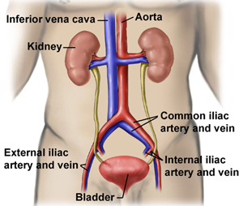
Dialysis Machines
Bowman’s capsule
The human kidney is an amazing organ. It has two essential functions, the excretion of urea, salts and water and the maintenance of water balance in the body. Each day the kidneys filter 180l of fluid out of the blood. Most of the fluid is reabsorbed with all the useful nutrients which the body needs such as glucose and amino acids. About 2l of urine is made and excreted via the bladder. This contains waste products such as urea which is toxic to the body.
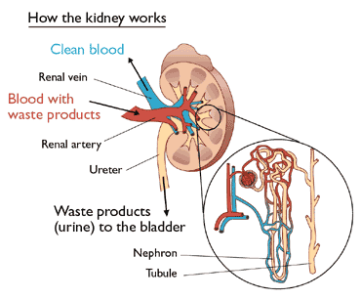
1

Filtration takes place in 3 million nephrons. Blood arrives at the capillaries of the kidney under pressure. Through holes in the wall of the Bowman’s capsule small molecules and water are filtered from the blood. In other parts of the nephron the molecules the body needs are reabsorbed.

Bowman’s capsule

nephron

2
3

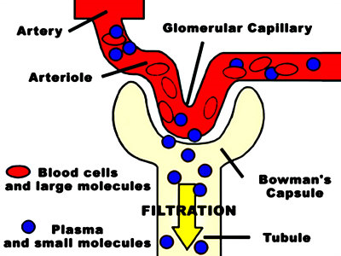

- Why do you think there are not normally plasma proteins in the urine even though they are in solution in the blood plasma?
…………………………………………………………………………………………………………………………………………………………………………………………………………………………………………………………………………………………………………
- In the case of certain injuries or diseases blood cells appear in the urine. What may have happened to allow this to occur?
…………………………………………………………………………………………………………………………………………………… ……………………………………………………………………………………………………………………………………………………

2.3 Dialysis worksheet page 2 of 2
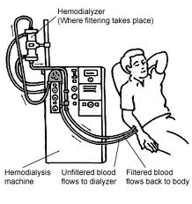
If kidneys fail death follows in about 4 days due to build up of urea and lack of control of water balance in the body. This can be prevented by the patient attending hospital 3 times a week for dialysis. Blood travels in a tube from the body and flows into the machine, where it passes next to a filter called the dialysis membrane. A specialized dialysis solution flows on the other side of the membrane. This is designed so that urea passes from the blood through the membrane into the dialysis fluid but glucose and amino acids do not. The blood is then returned to the body.

4

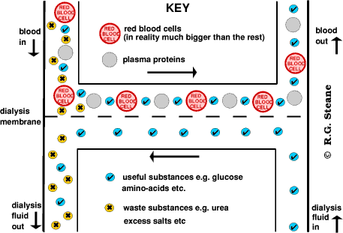

5

- Explain why the red blood cells and plasma proteins are not removed from the blood in dialysis? ………………………………………………………………………………………………………………………………………………………………………………………………………………………………………………………………………………………………………..
- Urea, glucose and amino acids are similar sized molecules. Explain why urea passes across the dialysis membrane but glucose and amino acids do not.
…………………………………………………………………………………………………………………………………………………………………………………………………………………………………………………………………………………………………………
- What would happen if water was used as the dialysis fluid?
………………………………………………………………………………………………………………………………………………………………………………………………………………………………………………………………………………………………………..
- How can dialysis be used to remove excess salts?
………………………………………………………………………………………………………………………………………………………………………………………………………………………………………………………………………………………………………
4.http://upload.wikimedia.org/wikipedia
5.http://healthsciences.merlot.org/images/18loop.gif
3.http://cache2.allpostersimages.com/p/LRG/3
2.http://3.bp.blogspot.com/_7MhVC-
1.http://www.yoursurgery.com/procedures/

