1.5 Other effects of collisions

The shot of the crossbow and the penetration of the head may have effects on the ballpoint. The two pictures below give examples of an effect that is meant here.

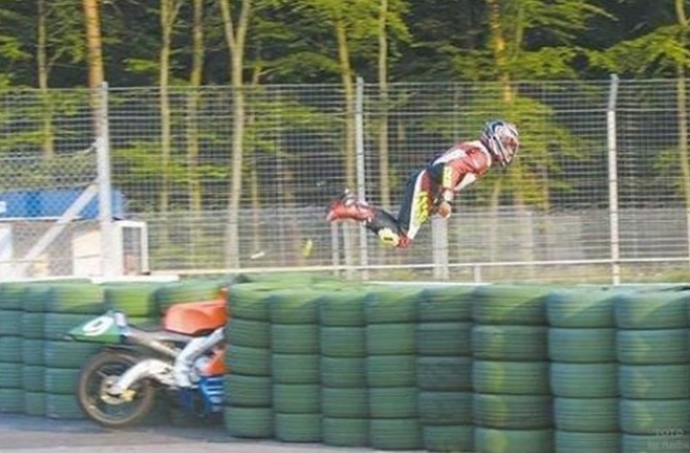

- Describe what you see in these pictures.

- Explain the physics behind these pictures, this phenomenon is called ‘inertia’.

- Discuss what the inertia effects in the ballpoint case might be.

- Give some examples of circumstances where you experienced the effect of inertia yourself.

