2.1 Face recognition

In this part of the series, we are going to look at faces. We start with a introductory game, where you can test how good you can remember faces.

- Visit http://www.bbc.co.uk/science/humanbody/sleep/tmt/ and play the game (be sure to take the breaks between the different rounds of this game)

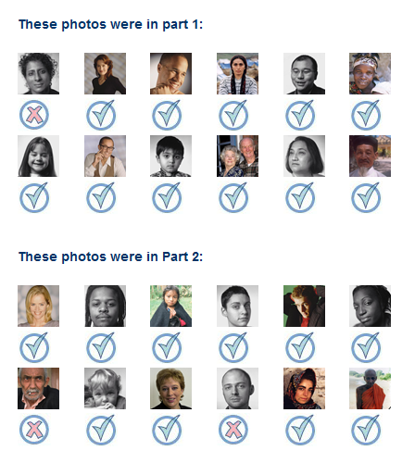 | 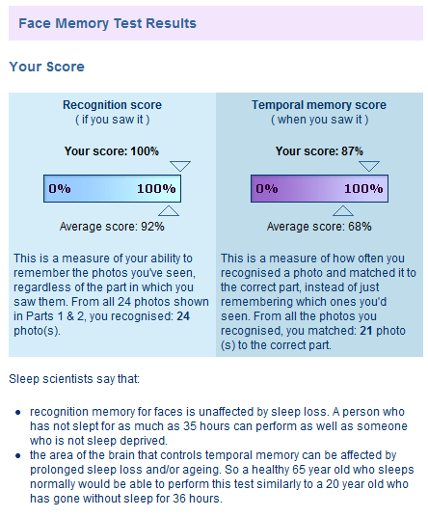
Answers and score from the BBC face recognition game

- Write down your score and make a screenshot from your results.

- Compare your results with these of your classmates.

- How do the results in class relate to the average scores given by the game itself?

- Discuss in class these results, which factors influence your memory? Which faces are easy to recognize?

