Tracing waste

Student’s worksheet

In the following tasks try to find out what happens to different kinds of waste in the environment and how long they decompose. There is a wood in your neighbourhood where you like walking in, cycling, you go to pick mushrooms or rest in some other ways. You discover on one of your walks someone has started an illegal dump:
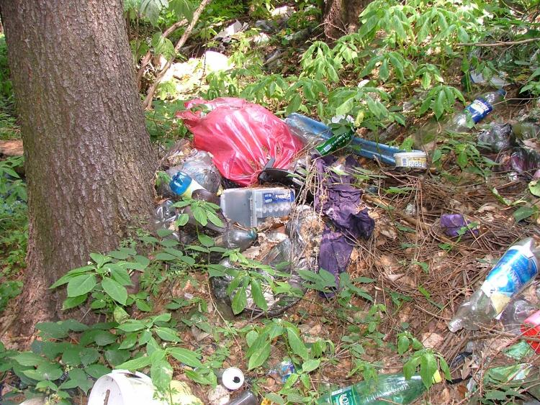

When investigating the rubbish more closely, you found:


- juice box
- cigarette end
- used tissue
- invalid credit card
- used chewing gum
- banana skin
- flat mobile phone battery
- marmalade jar made of glass
- perforated bicycle tyre
- plastic mineral water bottle
- apple core
- old magazine
- aluminium tin

You decide to watch how nature will cope with them itself.
Here begins your investigation.

Task 1
You will come back to the dump in the following time intervals. Next to each of them write which of the things should have decomposed.

- One month later
……………………………………………………………..
- Three months later
……………………………………………………………….
- Two years later
………………………………………………………………
- Five years later
………………………………………………………………
- Ten years later
……………………………………………………………….

Task 2
You are 100 years old and in perfect health. Which objects will still be at the dump? Next to each object write its time of decomposition.
............................................ ……… years
............................................ ……… years
............................................ ……… years
............................................ ……… years
............................................ ……… years

Task 3
Which objects from the dump could be recycled?
………………………………………………………………………………………………

Task 4
Which of the objects the environment can cope with itself without polluting the environment?
……………………………………………………………………………………………..
.................................................................................................................................

Task 5
On one occasion you will find a beautiful edible mushroom growing near the dump. Will you take it home and make scrambled eggs with it? Justify your answer.
………………………………………………………………………………………………
………………………………………………………………………………………………

Task 6
You have been watching the dump for a long time. Try to name everything that can influence the speed of decomposition of objects on it.
………………………………………………………………………………………………………………………………………………………………………………………………………………………………………………………………………………………………………………………………………………………………………………………………

Homework

- Find out how much waste you produce (municipal waste, or only plastic waste, alternatively) in your household during one year.
Procedure: collect waste (municipal waste, or only plastic waste, alternatively) during the whole weekend , weigh it and multiply its weight by the number of days of the year
- Search your neighborhood and find out if there are any illegal dumps there.
Note: You can support your findings with photos of the illegal dumps and present them to your peers (eg. by means of PowerPoint – presentation).
- Ask in the town or village where you live what possibilities there are for separating waste.
Note: You can extend the issue of separating of waste by other issues, eg. separation at home, at school, emphasise significance of waste separating.

