Resolubility of plastic and different materials in soil
Student‘s worksheet

Theoretical basis:
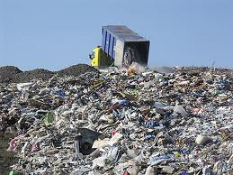
Waste is produced in every human activity. Its production and accumulation means a serious interference with the environment. Waste often contains substances that endanger almost all parts of the environment, i.e. quality of water, air and soil, they get into plants and through food chain threaten health and lives of animals and people. Right treatment of waste thus becomes as important as securing basic life needs. Apart from that, using waste as a secondary source of resources is becoming increasingly important..
The issue of waste is not new, it has always existed but became more widespread with a man appearing on the Earth. In the past, man only manufactured natural resources and waste was of the same substances. The environment was able to cope with them without problems. Solid waste decomposed in soil and enriched it with various precious elements. That way an eternal cycle was completed – everything that nature produces, returns to it after dying or being used. The cycle has been and increasingly is disrupted due to man. The environment is becoming increasingly contaminated with waste and its quantity exceeds self-cleaning ability of the nature.

Task 1
Rank the following waste according to the time of its decomposition in soil:
batteries and accumulators, apple core, newspaper and magazines, polystyrene, glass, rubber tyre, aluminium tins, plastic bottle and plastic bag.
- ...........................................................................................
- ...........................................................................................
- ...........................................................................................
- ..........................................................................................
- ..........................................................................................
- ..........................................................................................
- .........................................................................................
- .........................................................................................
- .........................................................................................

Task 2
Think about the fact how it is possible that some kinds of materials decompose in the environment within several weeks while some need hundreds of years for that. Use your knowledge of biology. The picture might be helpful to you.
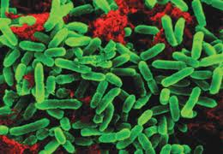
............................................................................................................................................................................................................................................................................................................................................................................................................................................................................................................................................................

Task 3
Answer the following questions. You have come across some of the answers in previous years of study. Now it is up to you to remember them☺.

- Choose a plastic product you come across every day and describe its properties.
....................................................................................................................................................
......................................................................................................................................................
.....................................................................................................................................................

- Name at least 10 products made of plastic.
..................................................................................................................................................
…………………………………………………………………………………………………………..
..................................................................................................................................................

- How would you explain the term biologically decomposable municipal waste?
.........................................................................................................................................

- Which of the above-mentioned waste is suitable for composting? Justify your answer.
.............................................................................................................................................
.............................................................................................................................................
.............................................................................................................................................

- Which waste you should in no case throw away into the environment? Justify your answer.
.............................................................................................................................................
.............................................................................................................................................
.............................................................................................................................................

- Write what chemical compounds a battery or accumulators contain. What dangerous gas compounds are produced in incineration of rubber tyres. Explain why they are dangerous for man and the environment.
....................................................................................................................................................................................................................................................................................

- Propose some solutions of waste disposal. Justify your answer.
....................................................................................................................................................................................................................................................................................................................................................................................................................................................................................................................................................................................................................
…………………………………………………………………………………………………………….

Homework
Imagine you gave a lecture on „Illegal dumps and their impact on the environment“. What would you talk about? Look up the necessary information and prepare several sentences you would say.

