Acid rains and plastic

Student’s worksheet
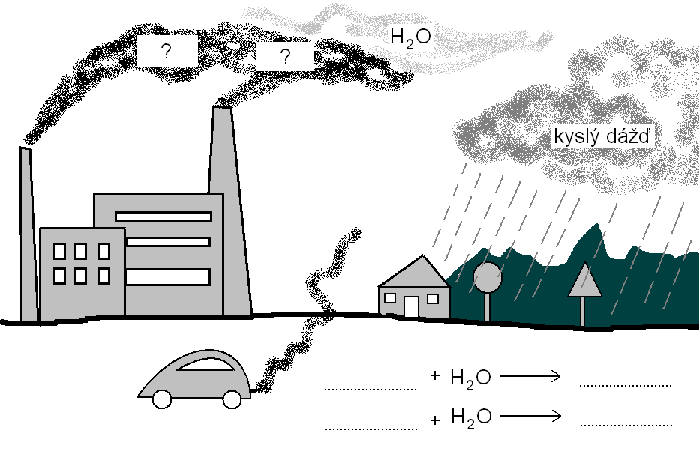
You have become familiar with the topic therefore it should not be difficult for you to tackle the following tasks.
Acid rain

How and why is acid rain produced?
................................................................................................................................................................................................................................................................................................................................................................................................................................................

Write at least three negative impacts of acid rain on the environment:
- ..........................................................................................................................................
- ..........................................................................................................................................
- ..........................................................................................................................................

Which materials are damaged by acid rain?
......................................................................................................................................................................................................................................................................................................................

What is pH of acid rain?
................................................................................................................................................

Discuss:
Are all materials damaged by acid rain? Which acids cause production of acid rains?
Work out specific solutions of acid rain prevention.

Task 1
You are going to study four kinds of plastic you have already become familiar with. Revise their names and make pairs:


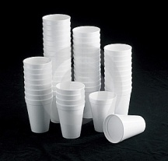
POLYETHYLENE

POLYPROPYLENE


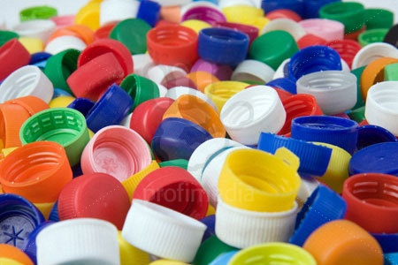
POLYSTYRENE

POLYVINYL CHLORIDE

Verify the impact of acid rains on plastic products based on the experiment.
Formulate a hypothesis:
.................................................................................................................................................................................................................................................................................................................................................................................................................................................................................

Task 2: Find out the influence of sulfuric acid and nitric acid with different pH on plastic materials

Materials:
Beakers, pipettes, sulfuric acid, nitric acid, different plastic materials: bottle cap (HDPE) , plastic bag (PP), water jar (PS), CD (PVC), chalk, cotton, wood, pH-meter

Procedure:
Pour diluted sulfuric acid with pH = 2 into first seven beakers. Put a piece of plastic into each of other four beakers and reference materials (chalk, cotton, wood) into the remaining three beakers. Repeat the procedure for pH of 3, 4, 5 . Complete the table with records of changes after one hour, one day and one week. Repeat the procedure with nitric acid as well and record the changes in the tables.

Findings:

Tab.1 : Effect of sulfuric acid on different materials depending on time

pH | Effects of sulfuric acid after | Plastic materials |  |  |  | Other materials
pH | Effects of sulfuric acid after | HDPE | PP | PS | PVC | chalk | cotton | wood
2 | One hour
2 | One day
2 | One week
3 | One hour
3 | One day
3 | One week
4 | One hour
4 | One day
4 | One week
5 | One hour
5 | One day
5 | One week

Tab.2 : Effect of nitric acid on different materials depending on time

pH | Effects of nitric acid after | Plastic materials |  |  |  | Other materials
pH | Effects of nitric acid after | HDPE | PP | PS | PVC | chalk | cotton | wood
2 | One hour
2 | One day
2 | One week
3 | One hour
3 | One day
3 | One week
4 | One hour
4 | One day
4 | One week
5 | One hour
5 | One day
5 | One week

Task 3
How do acid rains effect plastic products?
................................................................................................................................................

How did you prove the above fact?
......................................................................................................................................................................................................................................................................................................................

Compare effects of sulfuric and nitric acids on plastic products.
......................................................................................................................................................................................................................................................................................................................

Compare the resistance of plastic materials to acid rains with that of other materials that you studied.
.................................................................................................................................................................................................................................................................................................................................................................................................................................................................................

