Recycling plastics – using project-based method

1) Worksheet for „Journalists“
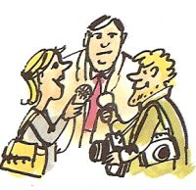
Identify yourself with smart journalists that want to reveal what is behind a particular problem. Your task is to understand the system of symbols you ca come across in almost all packages nowadays. Hardly anyone knows what different symbols mean and if producers put right symbols on packages. Your task will be to find out the truth and then to let it know to the world by means of a newspaper article.

Tasks for journalists:

- Have a look at different packages of food, PET bottles, boxes, etc. and notice different triangles and similar symbols.
- Tear off the symbols or draw them in the paper.
- Try to find out what different symbols mean and how you should handle the specific package.
- Try to find out how waste is handled in your town.
- Draw a simple comics „From the life of PET bottles“.
- Focus on separated waste and try to answer the question „ What happens to a PET bottle you throw into a bin for separated waste? “.
- Write a newspaper article in which you will depict your project

2) Worksheet for “Detectives“

Task: investigate life cycles of glass and plastic bottles.
- Find out the advantages and disadvantages of glass and plastic bottles. Incorporate the data into the table.
- Compare the life cycle of a glass and plastic bottle and try to make graphs describing the two cycles.
- How is recycling of glass and plastic bottles carried out?
- Find a plant in your neighbourhood where plastics are recycled and find out what products are made there and how.
- How long does it take paper, glass and plastic to decompose in the environment?
- Take a look in the history and find out who was the first to make a plastic and what name was given to the plastic.
- How are plastics made? Find out at least two procedures for their production.

3) Worksheet for „Common citizens“
Your group will represent common citizens who are trying to understand separating of waste. Your task is to find out what kinds of bins for separated waste are common in this country, what belongs to which container and what, on the contrary, must not be put into it.
Work out the answers to the following questions:
- What kinds of bins for separated waste are there?
- Make a table (tab.9) with an overview of waste that belongs and does not belong to the bins for separated waste. Give at least five examples for each item.

Tab. Proposal of a table for different waste that belongs or does not belong to the bin

Bin | Belongs | Does not belong
Paper
Plastics
Glass

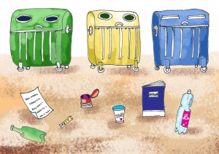
- How much waste do you produce per week? Gather all the waste during one day (eg. at the weekend), weigh it in the evening and multiply by seven.
- What percentage of the produced waste was represented by plastics?
- Do you separate waste at school? How?
- How far from the school are the nearest bins for separated waste?

4) Worksheet for „Employees of a firm processing plastics“

Imagine that the members of your group are employees of a firm that processes plastics.
- Find out if there are such firms in Slovakia.
- Invent a name for your firm.
- Divide the positions in the company in the group.
- Find out how such a company works.
- Find out three procedures used in processing plastics (state sources).
- Try to describe the procedures so that your peers could understand.
- Make a drawing and graph to describe the procedures and make them into a graph.
- Focus on recycling in more detail. If it is among the above mentioned procedures, devote most of your time to it, if it is not, describe it separately.
- Why is it not appropriate to incinerate PET bottles?

