Students’ worksheet
PAIRS?
Task 1: Print the following cards on a thick paper, cut to pieces with scissors and play the game PAIRS. What is difference? Two matching cards are not exactly the same, but there are some corresponding images, for example the polymer and its application, structure and its name etc. Follow them and try to learn as match as possible about the polymers. Enjoy!!!
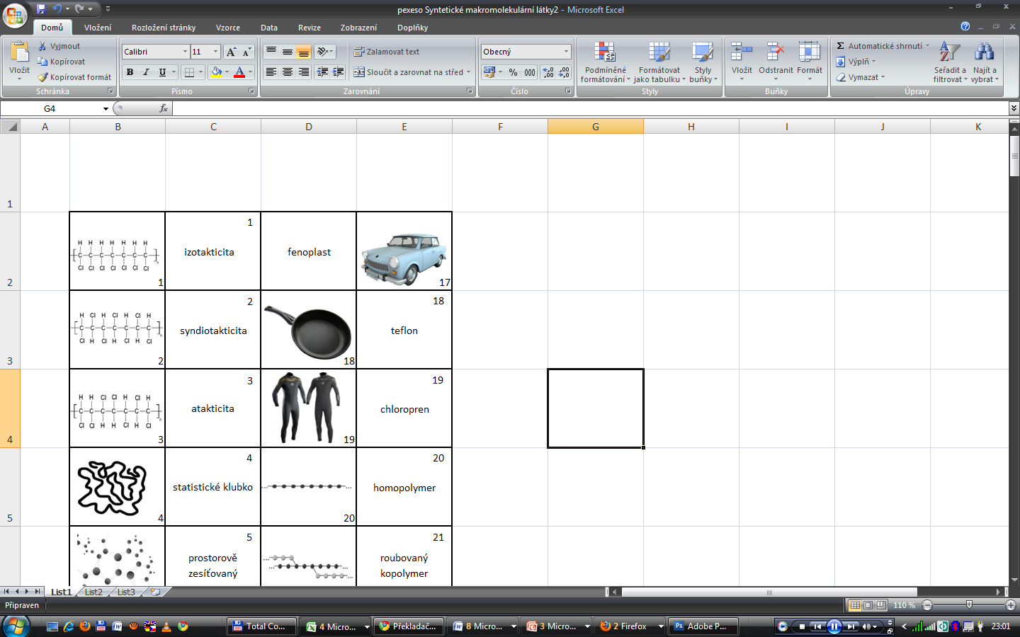
isotactic polymer
phenol plastic
syndiotactic polymer
atactic polymer
chlorprene
Statistic polymer

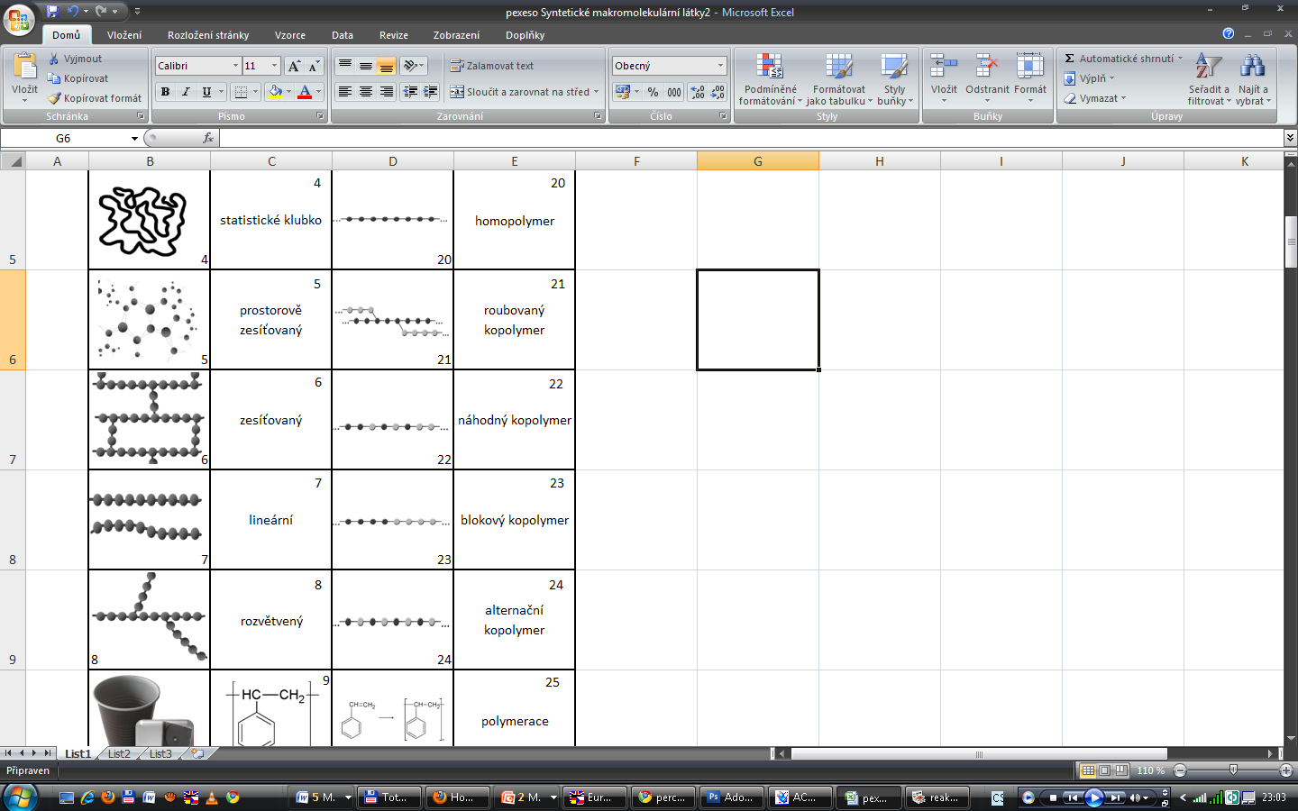
spacely
cross-linked polymer
cross-linked polymer
linear polymer
Syndiotactic polymer
block copolymers
alternating copolymers
Statistical copolymers
Graft copolymers
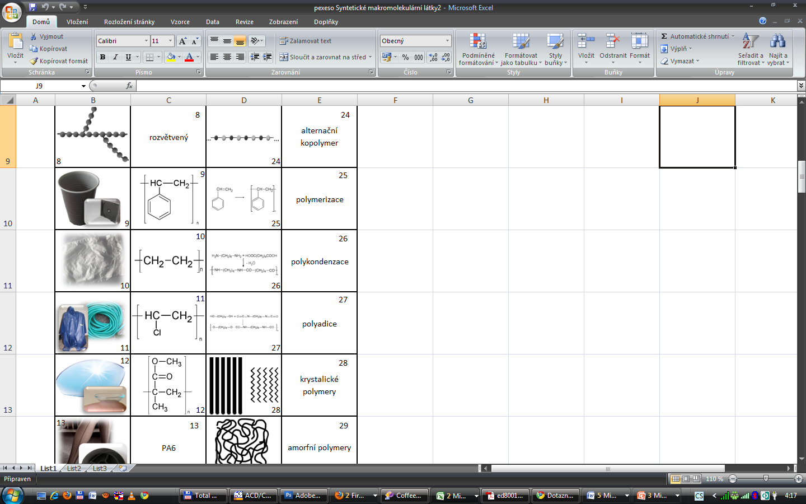
polymerization
polycondensation
polyadition
crystalline polymers
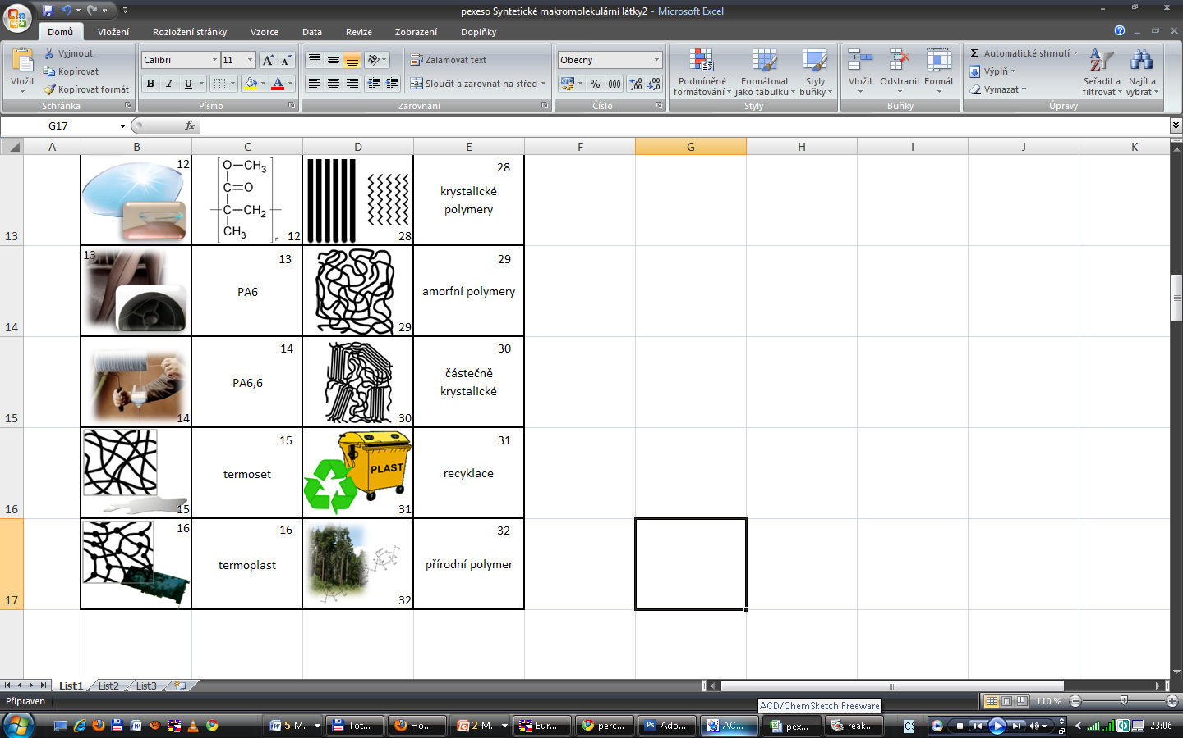
Amorphous polymers
partly crystalline polymers
recyclation
natural polymer
thermoset
thermoplastics

