Activity 10
Blood as a protector
White blood cells provide defense against foreign substances, viruses and bacteria.
You become an expert, at finding their presence in a blood smear.
To make blood cells easily recognizable, blood smeared on a slide is specially coloured.
You can easily recognize erythrocytes in the photographs of human blood smears. Their size is 7μm. They are without cell nuclei and they have a typical flattened shape. There is a hollow in the middle of the cell which can sometimes remind a nucleus, do not be mistaken!
Platelets are square and smaller than the red blood cells.
Several types of leukocytes exist: monocytes, lymphocytes, eozynophils, neutrophils and basophils. Pay attention to:
- cell size,
- presence of granules in the cytoplasm and their colour,
- the shape of nucleus

Read carefully:
- The nucleus of lymphocyte and monocyte is in the center of the cell, it looks dark blue or violet.
Small-sized lymphocytes are only slightly larger than red blood cells (10 microns). They have only a narrow strip of cytoplasm around the round nucleus. Medium-sized (15 μm) growing lymphocytes have more cytoplasm. Active lymphocytes, called killers, are the largest. They contain a few red granules in the cytoplasm.
Monocytes are the largest leukocytes (20 μm). They have a different shape of the nucleus, which may remind horseshoe, butterfly or embryo. Colouration of the nucleus and cytoplasm are less intense in comparison with monocytes. There are light pink granules in cytoplasm.
- Nuclei of neutrophils, basophils and eosinophils can be divided into segments, so it looks that we see more than one nucleus in the cell.
Neutrophils and basophils are about two times larger than erythrocytes (15 μm).
Eosinophils are slightly larger, measuring up to 17 μm. There are pink coloured granules in the neutrophil cytoplasm. Two parts of the nucleus of eosinophil can remind sunglasses. Eosinophils have brightly red colored granules resembling caviar.
Basophils have dark blue to black granules, which sometimes overlap the nucleus. They remind poppy seed cake.
Neutrophils have very small pink granules in the cytoplasm.

Look at these photos. How many types of while blood cells can you recognise?
(Photography: Edita Pauliková)

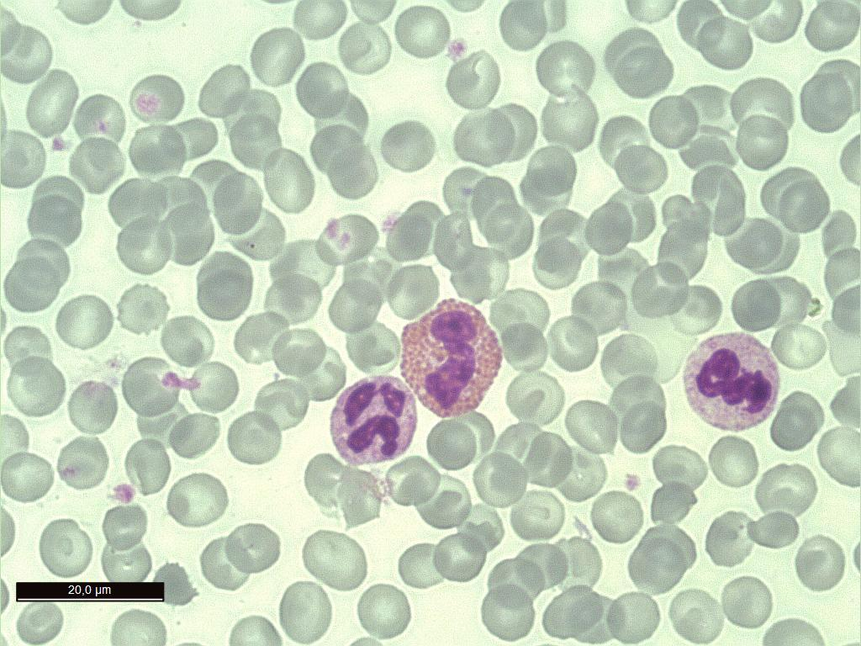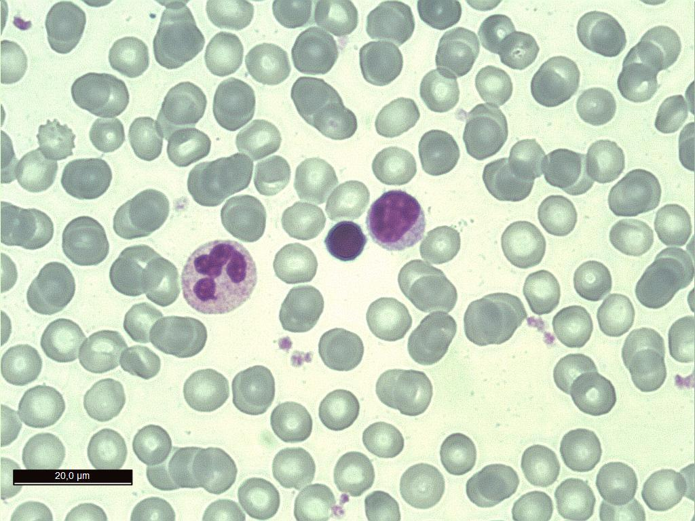

…………………………………………… ….…………………………………………..
…………………………………………… .……………………………………………..

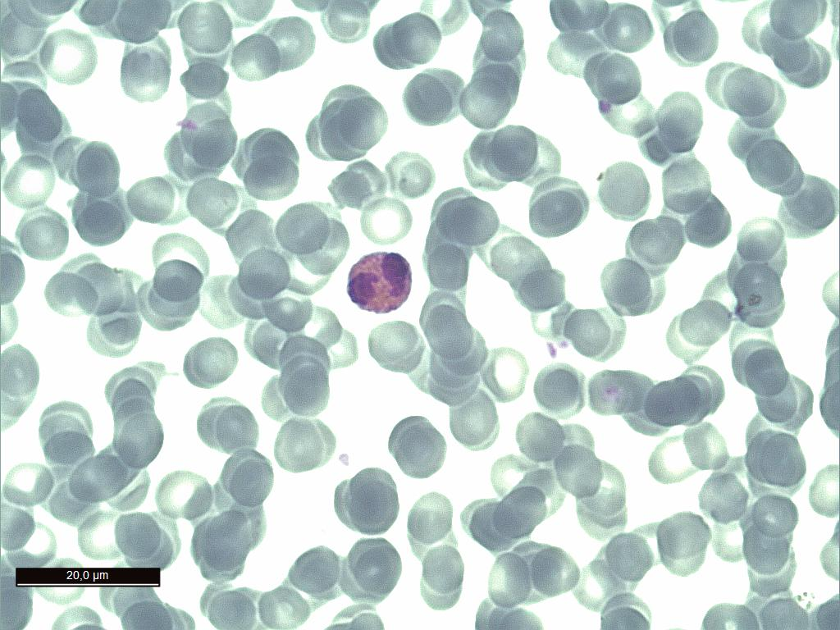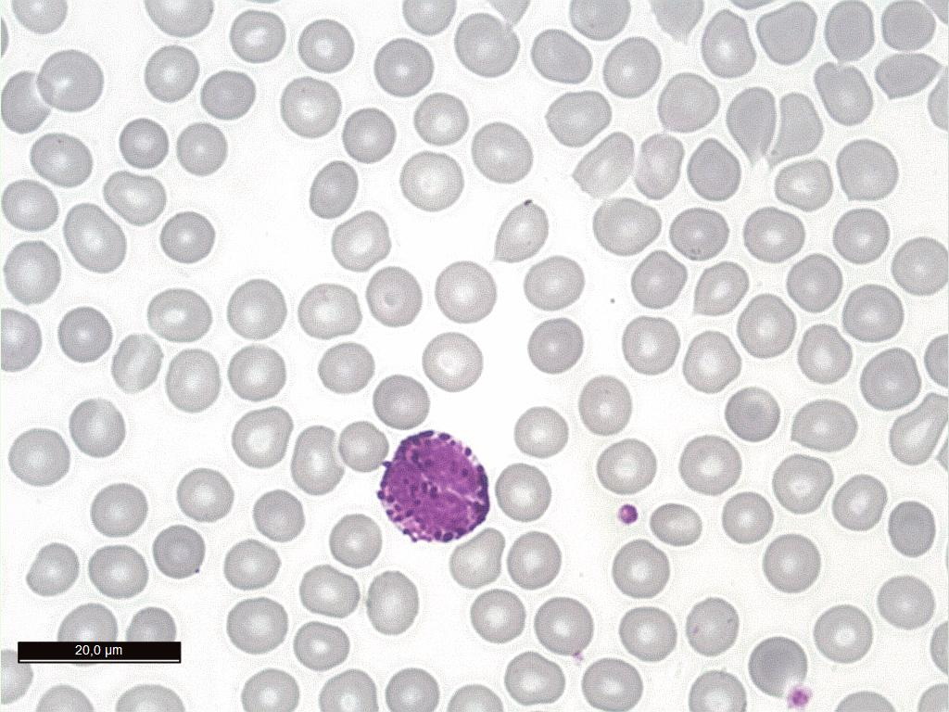

…………………………………………… ………………………………………........
…………………………………………… …………………………………………….

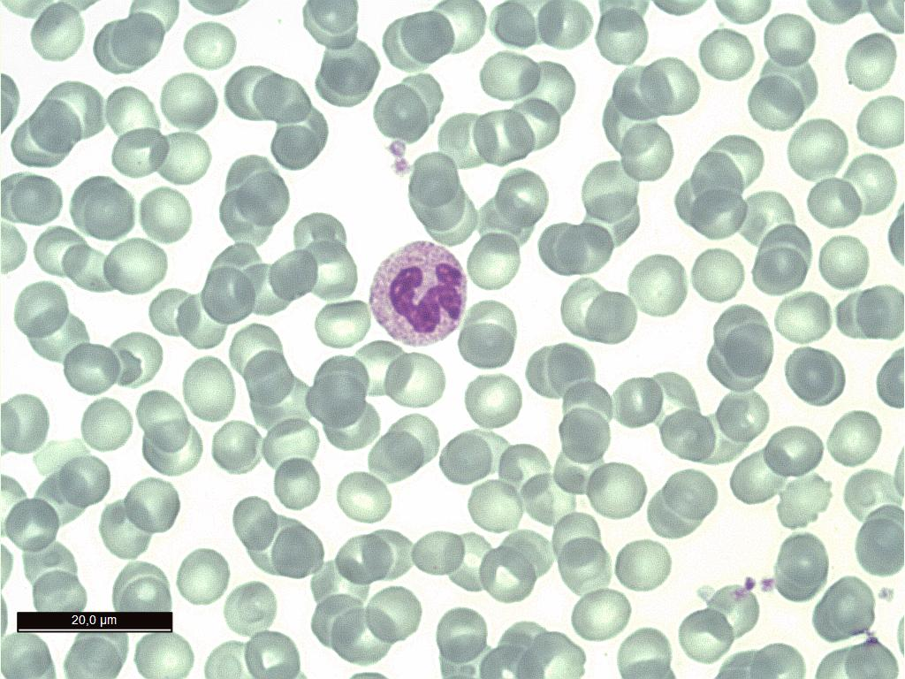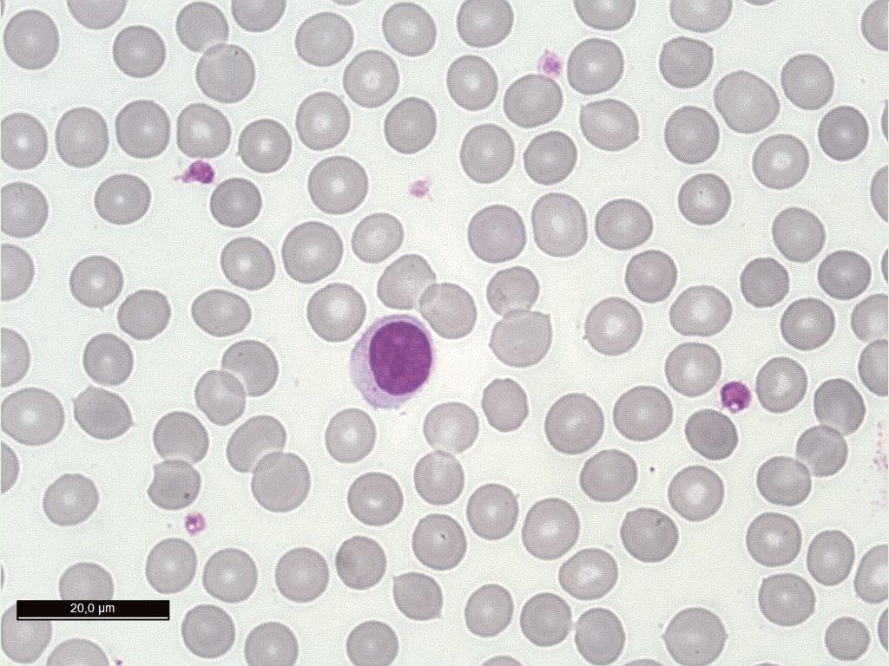
…………………………………………… ………………………………………......
…………………………………………… ……………………………………………

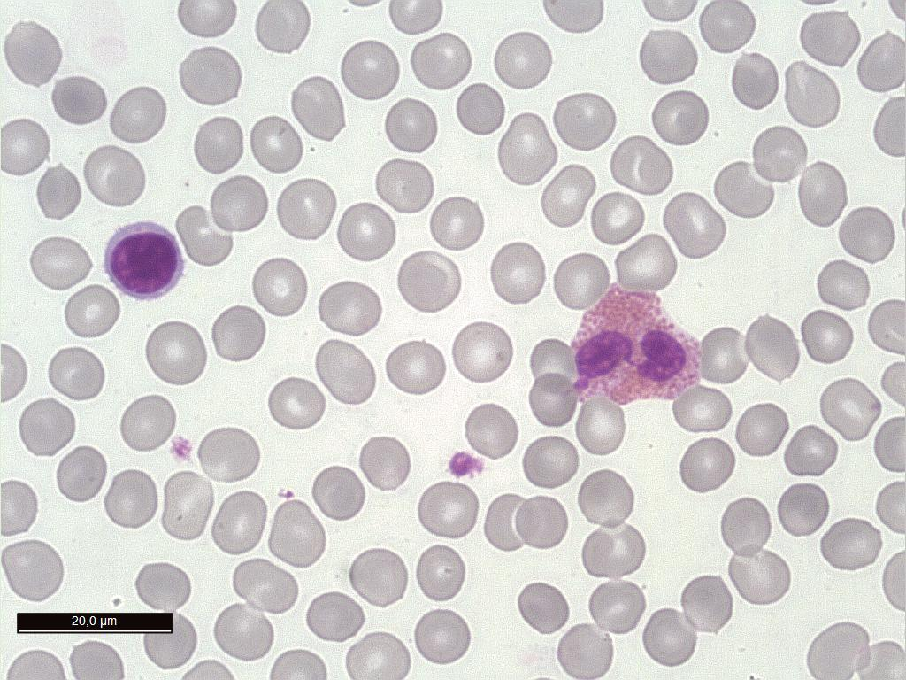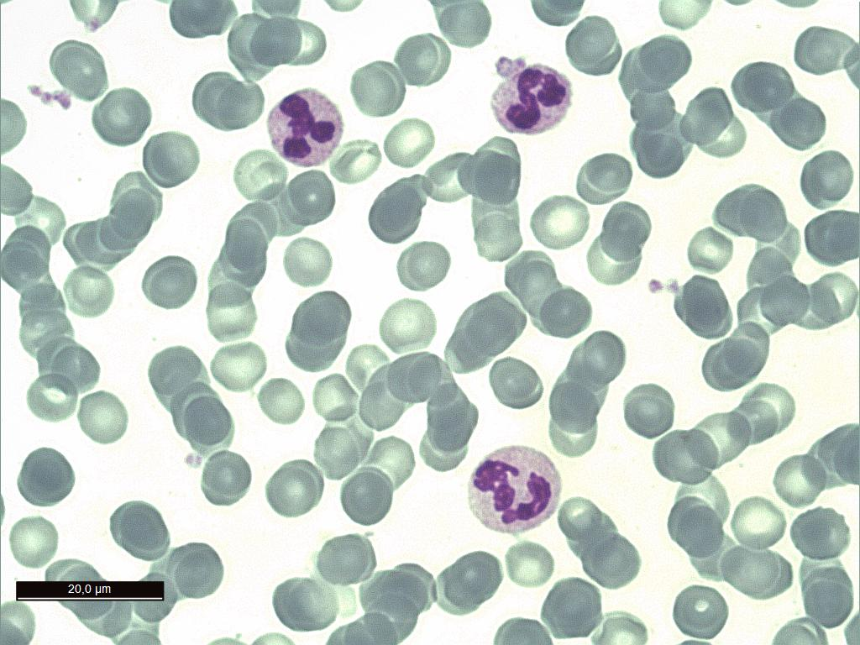
…………………………………………… ..………………………………………......
…………………………………………… ..……………………………………………

Explore the relationship between the colouring of leukocytes and their names!
Find more photos of microscopic sections of human blood on the internet. Identify
particular types of blood cells in the sample.

How do leukocytes protect our body from the pathogens?
What would happen if we lacked lymphocytes, phagocytes and other cells in our blood?
Do you think it’s good to have too many of certain white blood cells in one’s blood?

Find a blood clotting animation on YouTube.
What is the function of platelets?
Who needs to receive platelets by transfusion?

