Activity 3
Study visit at a transfusion center
We will meet staff of a transfusion center. Write down what you need to ask about the following aids to be able to complete the text prepared by your group with new information.
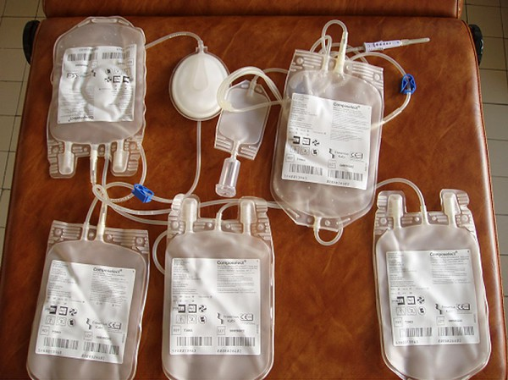 Disposable sterile blood taking set

…………………………………………………………?

Blood taken with anti-clotting agent

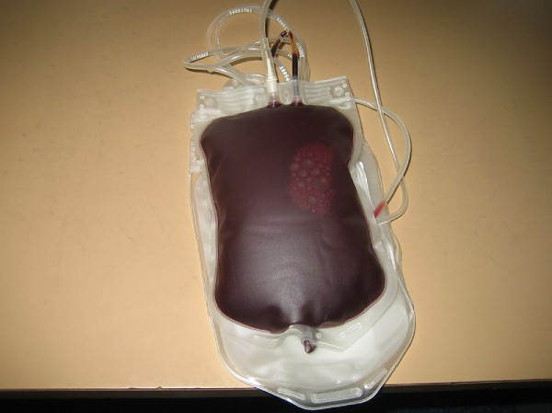
…………………………………………………………?
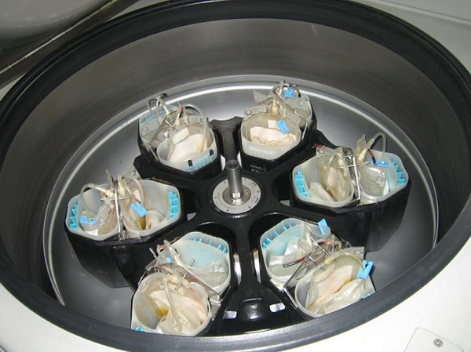 Bags of taken blood in a separator

…………………………………………………………?

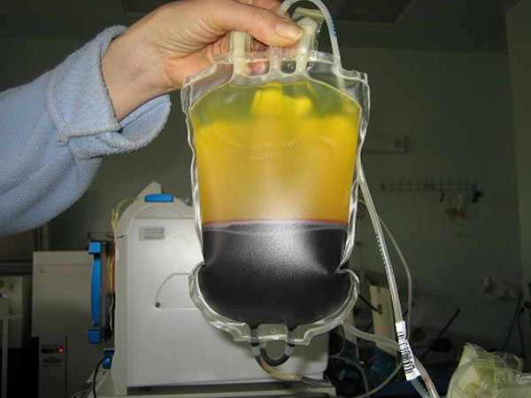
Three constituents of blood separated by a separator
…………………………………………………………..?

Look carefully at the process of separating blood constituents and ask questions:

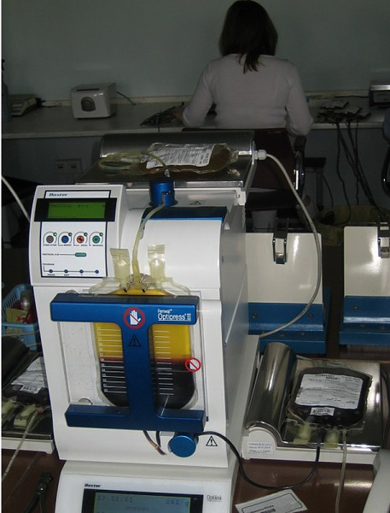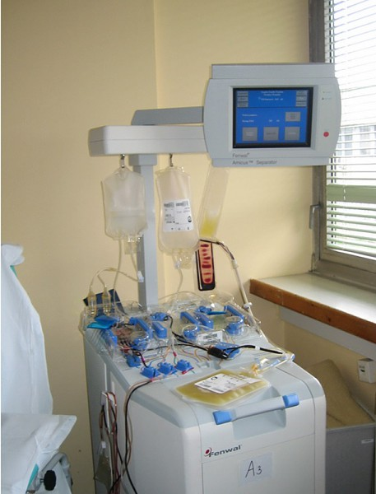

A press for separating individual Equipment for separating individual blood
constituents blood constituents

………………………………………………………….?
..………………………………………………………..?

Source of picture on this page: http://www.ntssr.sk

