Activity 4
Separating blood constituents
Exercise 1
Blood count
Study the photo carefully.
What objects can you see in it? What could it be?
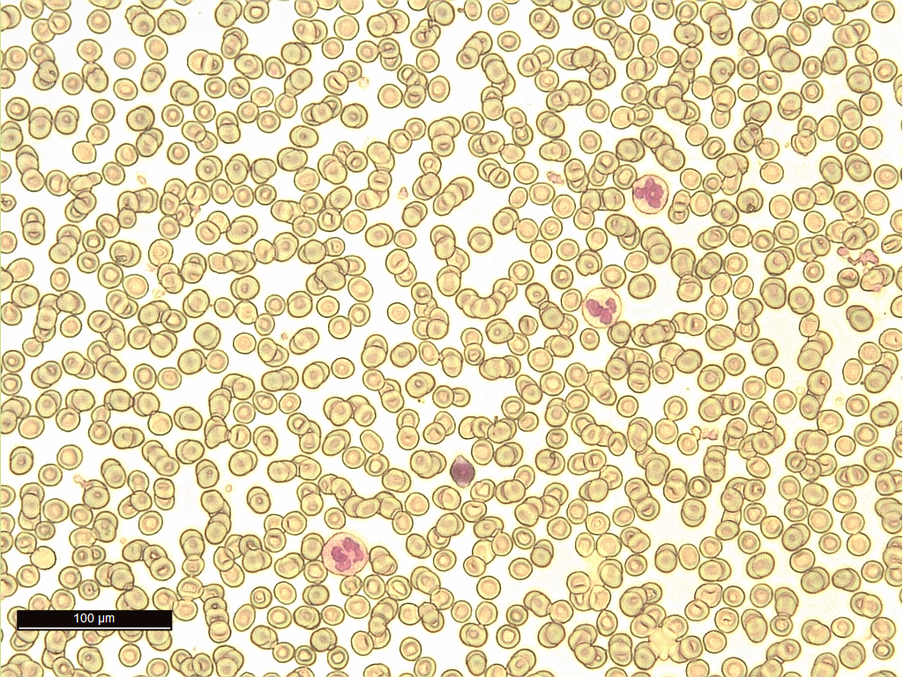
Photography: Edita Pauliková
Why doctors want to know patient’s blood count?
Design a way to find out the number of different blood cells in a given volume of blood. Invent and device a model by means of which you can clearly explain your idea.
Where can you find out optimal number of blood cells of a healthy man?

Exercise 2
Sedimentation
We know already that blood consists of several constituents: liquid plasma, red and white blood cells and platelets.
We have seen that the different constituents can be separated by a centrifuge. Sometimes, a doctor takes your blood to find out how fast the constituents get separated by gravitation effect. It is called examining sedimentation.

What a doctor learns from the speed of red blood cells sedimentation?

Choose from the aids that are available and design a model to observe sedimentation. Plan an experiment to find out the speed of sedimentation of particles at the certain time points.
Experimental design:

Write a procedure here how you would model sedimentation of blood cells using the aids that are available for you: | Make a drawing of the trial result here:  After 5 minutes  After 10 minutes
Which particles settled faster? Why?

Try to explain why erythrocytes fall down to the bottom faster when there is an inflammation in the body.

Would it be possible to make the particles settle faster when modelling sedimentation?

