Properties of plastic materials

Student’s worksheet
Plastic is a material one comes across every day. In the following experiments you will examine properties of different plastic materials. Before carrying out the experiments think about the fact which properties are important in producing and using plastic materials.
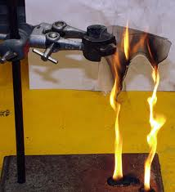

Discuss in groups:
Is plastic useful? Which are the properties that have enabled their widespread use? Do all plastic materials have the same properties? Does plastic undergo changes with time? Which properties of plastic would you like to study in more detail? Does plastic have negative properties as well?
Carry out the following experiments and record your findings step by step. Finally, complete the table in which you will summarize different properties of the examined plastic materials (PE, PP, PS, PVC). Next to each plastic write where in everyday life its qualities could be used.

List of activities:
    - Weight of plastic materials
    - Determining density of plastic materials by comparing with water density
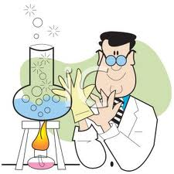
    - Combustion of plastic materials
1.2.4 Thermal stability of plastic materials
1.2.5 Verifying thermal conductivity of plastic materials
1.2.6 Electrical conductivity of plastic materials
1.2.7 Solubility of plastic materials
1.2.8 Reacting with acids, alkalis and solutions of salts
1.2.9 Tensile strength of plastic materials

