Worksheet: Fundamental frequency, double bass
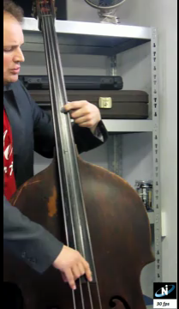
In music, certain frequencies are used and other frequencies are avoided. Some instruments can only produce the preferred frequencies (like a well tuned piano or guitar). Using other instruments (like a violin or double bass), it is still possible to produce all the frequencies. The bass player has to be sure to only play the specified notes. This means that a bass player has to put his fingers only on certain parts of the string to produce the right tones.
Using a video of a bass player who plays a simple tune, the position of the left finger of the bass player is being tracked. With this left finger, the bass player shortens the string and in this way determines the frequency of the tone produced with this finger. The part of the string below this finger is able to vibrate when plucked. This means that a high position in the diagram corresponds to a long part of the string that is able to vibrate. In the diagram below only positions of the left finger, at the moments when the right finger is plucking the string is displayed. This means that each cross in the diagram below corresponds to a tone produced.

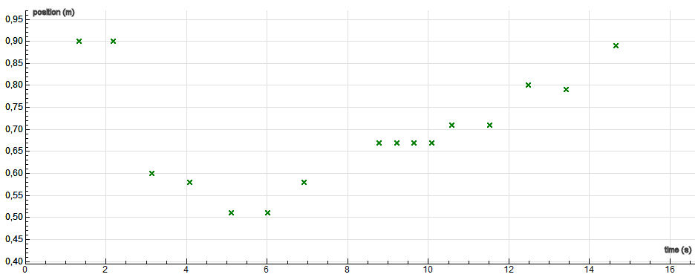
Diagram shows the position of the left hand (y-axis) in time (x-axis); each cross represents a tone produced. The y-coordinate is related to the frequency of the note.

- Most of the notes are played several times. How many different notes are used in this song?

- One tone used is slightly out of tune. The bass player hears this and moves his finger to adjust his intonation. The next time he plays this tone, it is in tune.
At which moment is the wrong tone played?

- As said before, the position of the finger of the bass player is being tracked. The lower the value in the diagram, the shorter the vibrating part of the string. Explain: is the wrong tone from question 2 a bit too high or a bit too low?

- The string is shortened with different steps. In music, these steps correspond to musical intervals. Starting at t = 5 s, the tone played is changed with each step by a whole tone or by a semitone. A whole tone is a bigger difference than a semitone. Between t = 5.0 s and t = 16.0 s the semitone is played once.
Can you see at what moment the semitone is played?

- Up to now you have only used qualitative analysis. With this question you are going to make a simple calculation and do some quantitative analysis.
The first major step in the tune (that is going from the second played tone to the third played tone at t = 2 s to t = 3 s) is called a fifth. This is a musical interval meaning that the frequency of the last tone is 1.5 as high as the frequency of the first tone (for example 100 Hz and 150 Hz or 220 Hz and 330 Hz).
Use this information to calculate the length of the string at t = 2.0 s.

- Can you make a guess on which tune is played?
Look at the intervals, look at the rhythm played. How sure are you about your answer? Is this tune popular in your country?
Take a look at http://youtu.be/yihwasEckfQ?hd=1 to find the answer.

