Worksheet: Fundamental frequency, guitar
When you pluck a string it vibrates with its fundamental (natural) frequency. In the previous activity, you have seen that a bass player uses his finger to shorten the string to specific lengths to play a certain tone. This is not necessary for a guitar because frets available on a guitar provide fixed string lengths.
In this experiment, you are going to measure the length of a guitar string when this string is shortened using frets and the corresponding fundamental frequency of the vibrations, and to find out the relationship between these two variables.

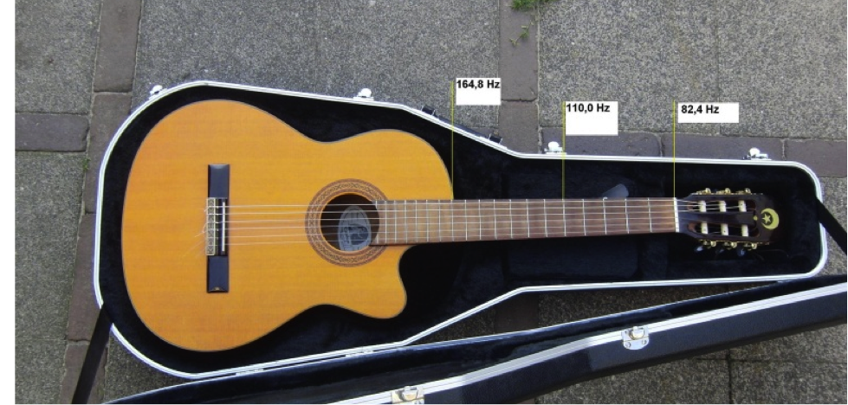

- Shorten a string by using a fret. Pluck the shorten string and measure the fundamental frequency of its vibrations.
- Measure the length of the shorten string.
- Record your measurements in a table.
- Repeat the measurements for different string lengths. Shorten the string by using different frets.
- Plot the frequency data against the corresponding string length.

- Find out the relationship between the fundamental frequency of string vibrations and its length?

