Worksheet: Melde’s experiment
In the previous experiments, you have discovered that each object has its own fundamental frequency. With the double bass and the guitar you have seen that the fundamental frequency of a string depends on the length of the string. But can the string vibrates with other than fundamental frequencies?
In this activity you are going to observe a string, which vibrates with different frequencies. In your experiment you will use the apparatus shown below.

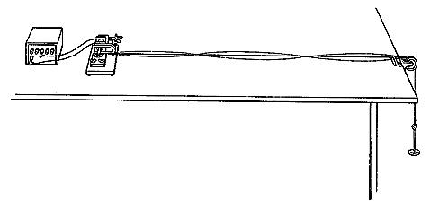

The function generator drives a mechanical vibrator. A string is attached to the vibrator at one end and a weight hanger at the other end, stretching over the pulley clamped to the table. The string, which is fixed at both ends, is driven with the same frequency as the frequency of the function generator. This experiment is called Melde’s experiment because it was first carried out by the German physicist Franz Melde.

- Set-up your experiment. Turn the generator and the mechanical vibrator on.

- Gradually increase the frequency of the vibrations and observe the vibrational patterns of the string.

- For some frequencies the vibrational patterns are really stable and have well-defined segments. These are called resonant standing waves. What do you think how these waves are created?

- Determine the frequencies necessary for generating four different vibrational patterns. Draw the resulting vibrational patterns – resonant standing waves of the string and write down their corresponding frequency values.

- Change the tension in the string and repeat the experiment. Again determine the frequencies necessary to obtain four different vibrational patterns. Compare the results of these two experiments.

The lowest frequency of vibration of a standing wave is the fundamental frequency, (also called the first harmonic). The higher frequencies of vibrations of standing waves are called harmonics (second, third, forth harmonic).

- Which of your drawn vibrational patterns represent the pattern for a standing wave with fundamental frequency?

- Indicate the nodes and antinodes in this standing wave. What is the distance on the standing wave between two nodes?

- Determine the relation between the length of the string L and the wavelength λ of the vibration for this standing wave.

- Which of your drawn vibrational patterns represents the pattern for standing wave with second, third and forth harmonics? Indicate the nodes and antinodes in each standing wave pattern.

- For each standing wave determine the relation between the length of the string L and the wavelength λ of the vibration.

- For each harmonics determine the ratio of its frequency f and the fundamental frequency f₀. How would you describe the relation between these frequencies?

