Worksheet: Standing waves in air, closed-end air column
With the Melde’s experiment you have looked at resonance in strings and found different possible modes of oscillations. In this activity you are going to examine the resonance frequencies of an air column.
The set-up of the experiment is shown on the photo below. A speaker is connected to a function generator which is placed above a tube. The tube is connected to a bottle and both are filled with water.

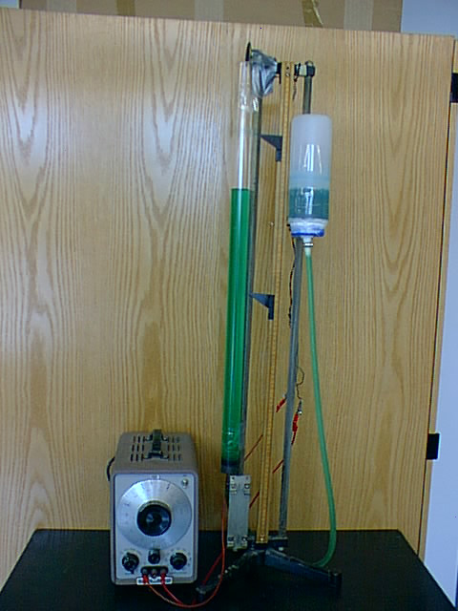
- Explain how the level of water in the tube can be changed.

- Investigate at which frequencies resonance occurs for a certain air column length (a certain water level).

- Record the air column length and frequencies at which the resonance of the air column can be heard.

- What is the fundamental frequency and what are the harmonics?

- Sketch a series of patterns showing the resonant standing waves that can be set up in in the air column. This you need to imagine!

- For each pattern derive expression for the length of the air column L and the wavelength λ of the standing wave.

- For each harmonics determine the ratio of its frequency f and the fundamental frequency f₀. How would you describe the relation between these frequencies?

- Compare these ratios with the ratios calculated for the string in Melde’s experiment. Are these ratios different or similar?
- Change the length of the air column and find out if the new occurring resonance frequencies have the same ratio.

