Activity 1.2.3 Combustion of plastic materials
Materials:
burner, scissors, incombustible mat, tongs, copper wire, samples of different plastic materials (PE, PP, PS, PVC)
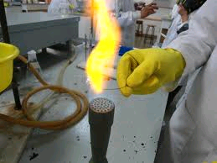
a) Combustion of plastic materials polyethylene (PE), polypropylene (PP), polystyrene (PS), polyvinyl chloride (PVC).
You know from your everyday life that paper and wood will burn down. In groups, discuss properties of plastic materials. Are they combustible? Do they produce any odour when burning?
Write down your hypotheses.
Hypotheses:
......................................................................................................................................................
.......................................................................................................................................................

Procedure:
Carry out an experiment to test combustibility of plastic materials. Observe and describe the changes in phases of the materials during the process of burning, describe the flame – its colour, smoke production, odour. Identify the character of fumes by means of universal indicator paper at the end of the test.
Describe the experiment in words.

Findings:
1. The findings can be summed up in the following table:

Tab. Summary of plastic materials properties
Type of plastic | Polyethylene | Polypropylene | Polystyrene | Polyvinyl chloride
Burning of plastic
Odour of plastic during burning
Beilstein’s test of halogens

- Match the plastic materials on the left with the properties on the right
( eg. 2A ).
1. polypropylene A. drops when burning
2. polyethylene B. does not drop when burning
3. polystyrene C. burns without soot
4. polyvinyl chloride D. burns with yellow flame
E. produces soot when burning
F burns with green flame
G. gases smell of paraffin H. gases have sweet odour
I. gases have acrid odour

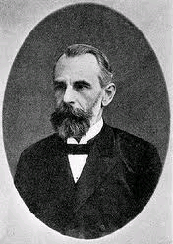
b) Beilstein’s test of halogens.

Friedrich Konrad Beilstein (1838 – 1906)

Procedure:
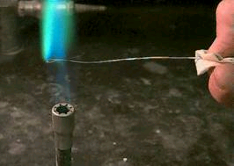
Ignite a copper wire in the flame of the burner. Use the wire to take a sample of a plastic and put it again into the flame of the burner. If halogens are present, the flame will become green. The essence of Beilstein‘s test is the fact that molten copper in the presence of halogens produces easily volatile cupric halides that cause the green colour of a flame.

Describe the following picture to describe the essence of Beilstein‘s test.
Picture:
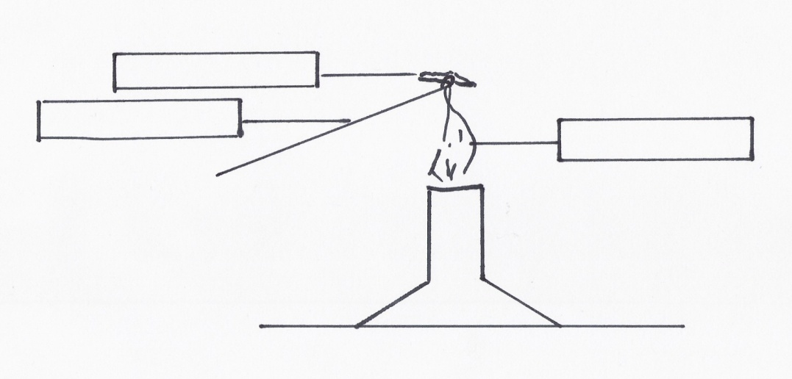

Notes:
The test must be carried out in the presence of fresh air because of the production of poisonous dioxin.
Dioxins (C₁₂H₄Cl₄O₂) are currently considered the most toxic chemical compounds accumulating in tissues of organisms. They comprise 210 chemical substances of the groups polychloro dibenzo-p-dioxins (PCDD) and dibenzofurans (PCDF).
The test of combustibility of plastic materials requires skillfulness and carefulness. Do not carry out the test of combustibility of PVC plastic in closed rooms!
Disposal of waste:
Collect the used plastic in collecting receptacles.

Findings:
Write them into the last line of the table for activity 3.2 a).

