Activity 1.2.4 Thermal stability of plastic materials
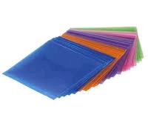
Thermoplastic (plastomers) are plastic materials which become soft and plastic (soluble by heat) when exposed to heat. Polyethylene (PE), polypropylene (PP), polyvinylchloride (PVC), polystyrene (PS) belong to this group.

Materials:
Beaker, burner, matches, above mentioned types of plastic, cotton, metal and wood

Procedure:
Carry out an experiment in which you will observe the change of shape of thermoplastic in boiling water. Compare the change with that of selected natural materials.
Put the appropriate plastic, cotton, metal and wood into boiling water and close the container. Take them out of water some minutes later and write your findings into the table.

Findings:

- Complete the table:

Plastic | Change of structure in 100 ºC water | Natural materials | Change of structure in 100 ºC water
PVC |  | Cotton
Polyethylene |  | Metal
Polypropylene |  | Wood
Polystyrene

- Which plastic materials used in everyday life cannot be exposed to high temperatures? Justify your answers.

..................................................................................................................................................................................................................................................................................................

3. Have you come across „melting „ of a plastic product in everyday life?
..................................................................................................................................................

