Activity 1.2.8 Reacting with acids, alkalis and solutions of salts
Materials:
Test tubes, clap stand , different kinds of plastic, cotton, metal and wood
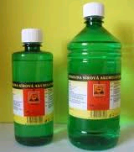
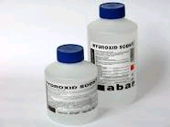
Procedure:
Before the experiment, formulate your hypotheses about action of acids, alkalis and solutions of salts on plastic materials and natural substances.

Hypotheses:
.......................................................................................................................................................
.......................................................................................................................................................

Carry out an experiment in which you will study the resistance of the above-mentioned substances to the action of acids, alkalis and solutions of salts.
Fill the test tubes with different acids, alkalis and solutions of salts. Put a particular kind of plastic, cotton, metal and wood into each test tube. Write your findings into the table:

Findings:

1. Complete the table:

Plastic | Time of action | Acids |  | Alkalis |  | Solutions of salts
PVC | 5 minutes
 | Two hours
 | week
Polyethylene | 5 minutes
 | Two hours
 | week
Polypropylene | 5 minutes
 | Two hours
 | week
Polystyrene | 5 minutes
 | Two hours
 | week
Natural substances | Time of action | Acids |  | Alkalis |  | Solutions of salts
Cotton | 5 minutes
 | Two hours
 | week
Metal | 5 minutes
 | Two hours
 | week
Wood | 5 minutes
 | Two hours
 | week

2. Compare the resistance of organic substances (cotton, wood) with that of plastic materials (resistance to the action of acids, alkalis and solutions of salts).
..............................................................................................................................................................................................................................................................................................................

3. A lot of chemicals are kept in plastic receptacles.
How is it possible? ......................................................................................................................................................

