Activity 1.2.2 Determining density of plastic materials polyethylene (PE), polypropylene (PP), polystyrene(PS), polyvinyl chloride (PVC) by comparing with water density.
Materials:
Glass beaker of 250 cm³, samples of different plastic materials (PE, PP, PS, PVC)

Procedure:
Study the plastic objects and formulate hypotheses about their density in comparison with that of water. Write down your hypotheses.
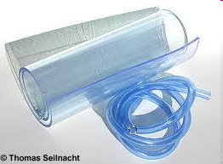
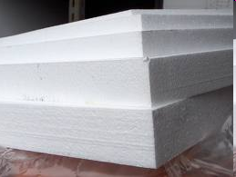
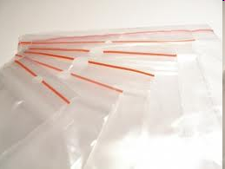
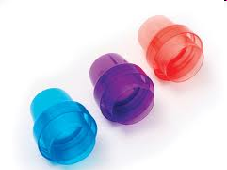

PE PP PS PVC

Hypotheses:
..................................................................................................................................................
..................................................................................................................................................

Propose a procedure by which you can verify and compare the density of the above plastic materials with that of water. You can look up water density in the chemical tables. Describe the procedure in words.
Procedure:
..............................................................................................................................................................................................................................................................................................................

Problem solving task:
Devise a procedure for exact setting the density of selected plastic materials.
.............................................................................................................................................................................................................................................................................................................. .......................................................................................................................................................

Findings:
1. In the picture, there is the result of the experiment to determine density of different plastic materials of PE, PP, PVC, PS. Write the names of the materials into the bubbles in such a way that it complies with the findings of the experiment.
Picture:
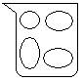

2. Complete the text with the following expressions:
„floats on water“; „falls to the bottom of the beaker“ „bigger, smaller“

The density of water is ________ g/cm³
Polyethylene ____________, therefore its density is _________________ than that of water. Polystyrene ______________, therefore its density is ________________ than that of water. Polyvinyl chloride ____________________, therefore its density is _____________ than that of water. Polypropylene _____________________, therefore its density is ___________ than that of water.
Complete:
Which formula can be used for exact determining the density of plastic materials?
ρ = __________

