Exemplary Classroom Materials (Subunit 1)

1.2
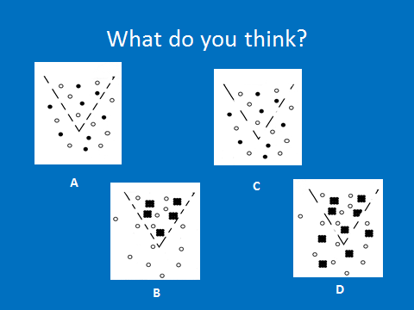

From your observations in the activity, suggest which model above describes your separation.

