Activity 1.6. Car Engines Worksheet
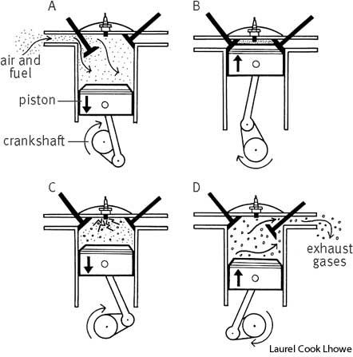
Car engines usually have 4 cylinders. Inside the cylinders a petrol air mixture explodes pushing down a piston which pushes the wheels around. The 4 cylinders are coordinated like the pedals on a bike so there is always one pushing down to turn the wheels.
It is important that there is the right mixture of air and petrol to cause the best explosion in the cylinder.
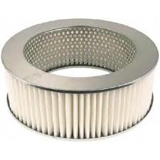

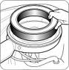
Air is filtered before it enters the engine. If the air filter gets clogged not enough air gets in and the petrol does not burn well. If the air is not filtered dust causes problems in the cylinders.
2.
1.

4.


In racing cars they improve the performance of the engine by using a very thin filter which lets through much more air to mix with the fuel.
3.
3.

- Why is it necessary to change the air filter on the car after 12,000 miles?......................................……………………………………………………………………………………………………………………………
3.
- What clogs the air filter? ………………………………………………………………………………………………………………………………………………………………………………………………………………………………………

- Why does the engine stop working well if the air is not filtered?
………………………………………………………………………………………………………………………………………………………………………………………………………………………………………………………………………………………………………….……………………………………………………
- What is the advantage of using a thin filter in a racing car? What is the disadvantage?...........
………………………………………………………………………………………………………………………………………………………………………………………………………………………………………………………………………………………………………………………..……………
1.http://images.yourdictionary.com/images/science/ASintcom.jpg
2.http://image.tradevv.com/2009/07/28/yuebingxy_448926_600/car-air-filter-car-filter-auto-filter.jpg
3.http://4.bp.blogspot.com/_ddqtkOiADuo/SrO4wb_9cWI/AAAAAAAAA1c/fyvKOjsRwnY/s400/ferrari-formula-one-racing-car.jpg
4.http://www.napacanada.com/en/NAPAKnowHow/~/media/Images/NAPAKnowHow/air_filter_2.ashx?w=140&h=141&as=1

