Worksheet 2.3: Studying Real and Apparent Depths

1. An object is placed at point ‘P’, as in the diagram, and illuminated by a light source. Two reflected rays from this object are shown in the diagram, and both are incident on a glass block.
Roughly sketch the path that light takes through the glass, and the path light takes on leaving the glass block.
Glass Block
P
Reflected rays

2. An observer now looks at the object at point P through the glass block. From your sketch above, is it possible to determine where this object will appear to be located? How did you determine this?
___________________________________________________________ ___________________________________________________________ ___________________________________________________________

Show this apparent position of the object on the above diagram.

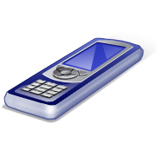
L
3. Place the small piece of cork at the base of your graduated
cylinder. Position your mobile phone at the top and take a
photograph of the cork.

Measure the distance from the base of the cylinder to the
phone.

L = ___________ cm

4. Now add some water to the cylinder and measure the height
H
of the water from the base. Take a photo of the cork again.

Repeat this for at least five different heights of water.

H₁ = ___________ cm
H₂ = ___________ cm
H₃ = ___________ cm
H₄ = ___________ cm
H₅ = ___________ cm

As the cork gets closer to the phone, would you expect the cork to appear larger, smaller, or stay the same size in the photograph? Why?
___________________________________________________________ ___________________________________________________________

5. Pour the water out of the cylinder and place a coin at the base. Take a photo of the coin, as before. Fill the cylinder completely with water (leave enough room so the phone doesn’t get wet!). Now photograph the coin through the water.

6. Upload your images to a computer and use software to crop the images so that they only include the cork/coin.

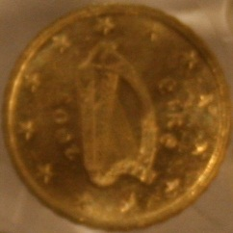

Determine the width of each cropped image in pixels and use this information to fill out the following tables:

Cork
Distance from Camera (cm) | Width of Image (pixels)
L – H₁ =
L – H₂ =
L – H₃ =
L – H₄ =
L – H₅ =

Coin
Width of Image (pixels)
Through Air:
Through Water:

Does the width of the coin in the image change with the addition of water?
___________________________________________________________

7. Plot a graph of Width of Image (in pixels: y axis) versus Distance from Camera (cm: x axis) for the cork.

Since you know the size of the image when the coin was photographed through the water, can you determine from your graph how far the coin appeared to be from the camera?

Apparent depth = __________________ cm

What was the actual depth of water?

Real depth = __________________ cm

