Activityy 3.3: Research into the process of the production of textiles

General way from raw material to fibre¹⁶

plant / crop, animal
cellulose, cotton, wool, silk
fabric
petroleum / fossil fuel, natural gas
hydrocarbons
natural fibre
thread
spun fibres
fabric

Synthesis of monomeric building blocks (multiple
reaction steps)
- polymerisation or
- condensation polymerisation or
- polyaddition or
- reaction with polymers
- washing

- dissolving of cellulose
- transfer to textile pulp

synthetic fibre

- preparation
- preparation
- lubrication

thread
spun fibres

- sizing
- pre-treatment
- dying plant
- sizing
- pre-treatment
- dying plant

- pre-treat- ment (conside-rably more chemical processes than with synthetic fibres)
- dying plant
- finish (more than with synthetic fibres)
textiles of everyday life
clothes, home textiles, technical textiles
- pre-treatment
- dying plant
- finish

¹⁶ Source (adapted from):
Fonds der Chemischen Industrie im Verband der Chemischen Industrie e.V. “Informationsserie TEXTILCHEMIE“. page 12.

Worksheet 6: The spinning process¹⁷

Tasks:
- Find out about different spinning processes to obtain synthetic fibres.
- Describe the processes and find out which process can be used for which synthetic fibre.

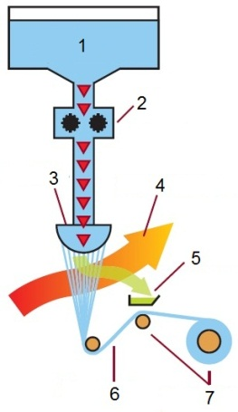 | The dry spinning process  1.  2.  3.  4.  5.  6.  7.
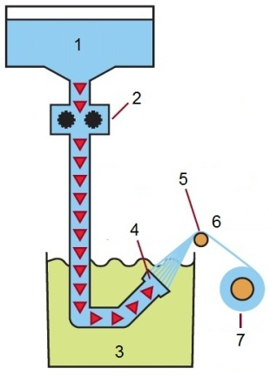 | The wet spinning process  1.  2.  3.  4.  5.  6.  7.
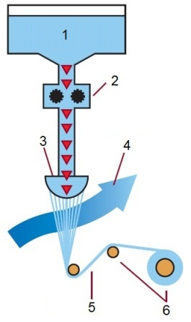 | The melt spinning process  1.  2.  3.  4.  5.  6.  7.

¹⁷ Source of figures: Fonds der Chemischen Industrie im Verband der Chemischen Industrie e.V. “Informationsserie TEXTILCHEMIE: Arbeitsblätter“. page 3.

Solution to Worksheet 6: The spinning process¹⁸

Production processes of textile fibres – the spinning process
There are several methods for making semi-synthetic fibres. Research for example the methods for making acetate silk or rayon, copper yarn or viscose. There exist also several different methods of spinning, i.e. to twist fibres together to make yarn: the dry spinning process, the wet spinning process and the melt spinning process (for more information see: http://www.ivc-ev.de/live/index.php?page_id=58).

The spinning process
Synthetic fibres can be obtained by different manufacturing processes. Endless yarns called filaments are produced from spin mass. This is pressed through a spinneret. A spinneret can be compared to a bathroom shower head as the spinnable matter (liquid or viscous) must be carefully filtered and is pressed through these from one to several hundred tiny holes or rather openings. When the filaments exit these holes, the liquid polymer is in the spinning process. Then it is first converted to a rubbery state (process of extrusion) and then solidified (process of solidification).
Wet spinning, dry spinning, melt spinning, and gel spinning are the four processes of spinning filaments of manufactured fibres.

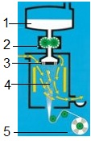 | The spinning process  (common basic processes)  - a container holds the spinn mass  - the spin mass is dosed by a spin pump  - the spinneret  - the filament is formed in a medium  Drawing the filaments may impart strength as drawing pulls the molecular chains together and orients them along the fiber axis which creates a stronger yarn.  - the filaments are gathered to a filament yarn and spooled by a special device
The dry-spinning process  A container holds the spinn mass (1) which is soluted in an organic solvent. The spin mass is dosed by a spin pump (2) and exits the spinneret (3) into a spinning duct. By evaporating the solvent in a stream of carefully blown in (warm) air or inert gas (4) the solidification of the polymer/filaments is achieved. The filaments are not allowed to touch each other in order not to stick together. The solvent is recaptured (5) and used again. Then the drawing/ stretching of the filaments takes place (6). Finally, they are wound up (7).  This process is applied to produce fibres of acetate, triacetate, acrylic, modacrylic, PBI, spandex, and vinyon. |  | 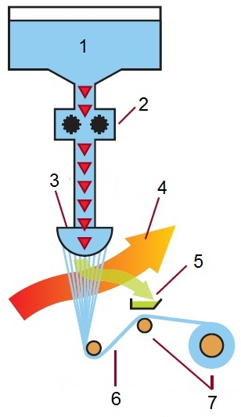
The wet spinning process  In the wet spinning process, which is the oldest used process, the solution is extruded/ pressed directly into the precipitation liquid.  A container holds the fibre-forming substance (spin mass) which is dissolved in a solvent (1). The spin mass is dosed by a spin pump (2). The spinnerets (4) are submerged in a chemical bath (3). When the filaments emerge from the spinnerets, they precipitate from solution and solidify. This is due to a bath which causes the filaments to coagulate. They are pulled towards the top (5). As they are still soft, the drawing/ stretching of the filaments takes place (6). By modifying the stretching, the fibres can be changed according to their specific purpose regarding their stiffness/ resistance and stretching/expanding behaviour. Before they are finally wound up (7) they need to be cleaned from chemicals.  By this process acrylic, aramid, modacrylic, rayon, and spandex can be produced. |  | 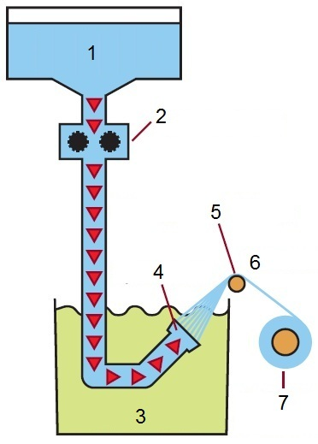
The melt spinning process  The melt spinning process is a simple and economic process. In melt spinning, the fibrous raw material needs to be meltable (must not decompose at its melting temperature). The fiber-forming substance is heated and melts (1) before being filtered and dosed by a spin pump (2). Then the extrusion through the spinneret (3) takes place – the melt is pressed through it. The rays of the spin mass flow into a duct several meters high to solidify by cooling via a uniform cold air stream (4). They have to solidify rapidly in order to resist the haul-off speed. Then the drawing/ stretching of the filaments takes place (5). Finally, they are wound up (6).  In this manner, fibres such as nylon, polyester, olefin, saran (polymers made from vinylidene chloride along with other monomers), and polyphenylene sulfide (PPS) (sulfar) are produced. |  | 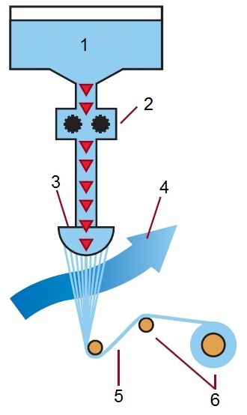

The gel spinning process
In order to obtain high strength or other special fibre properties this process is used. During the step of extrusion, the fibrous material (polymer) is not in a true liquid state as the polymer chains are bound together at various points in liquid crystal form (in a true solution they would be completely separated). In this process the filaments first pass through air and are then cooled further in a liquid bath. The filaments produced by this method have strong inter-molecular forces which can increase the tensile strength of the fibers. The emerging filaments exhibit a high degree of orientation relative to each other which further enhances strength. In this manner high-strength aramid or polyethylene fibres are produced.
¹⁸ Sources:
- Fonds der Chemischen Industrie im Verband der Chemischen Industrie e.V. “Informationsserie TEXTILCHEMIE: Arbeitsblätter“. page 24.
- http://fonds.vci.de/template_downloads/tmp_fonds.vci.de/119988FCI_Textilchemie_Textheft_20070301.pdf?DokNr=119988&p=111
- Industrievereinigung Chemiefaser e.V. (Herausgeber): Chemiefasern: Von der Herstellung bis zum Einsatz. Frankfurt/Main. Kapitel 6.1 „Fasern nach Maß“. English version available see “Man-Made Fibres – The Way From Production To Use” p. 15. http://www.ivc-ev.de/live/index.php?page_id=92
- Manufacturing: Synthetic and Cellulosic Fiber Formation Technology. American Fiber Manufacturers Association / Fiber Economics Bureau. 2012. Zugriff: 28.02.2012. http://www.afma.org/f-tutor/techpag.htm

