Activity 3.6: Keeping textiles clean

Worksheet 8: Research project

Task:
find out about the following:
- What are your clothes made of?
- What all can you do with your clothes in order to get them clean? Consult the care label for details. For information on what the icons mean, look for information in books or the internet.

For a list of care icons (there are icons for washing, chemical cleaning, ironing, drying and bleaching), see for example:
http://www.textileaffairs.com/docs%5Ccommon-050608.pdf

Worksheet 9: How bleaching agents work²¹

Besides surfactants, which are used as washing active substances, heavy-duty detergents often include bleaching agents. These remove dirt by means of oxidation processes. Bleaching agents were not always present in laundry detergents. At one time, laundry used to be spread out on the grass to be bleached by natural ultraviolet radiation from the sun. During the course of time, as laundry detergents underwent further development, a variety of bleaching agents came to be used.
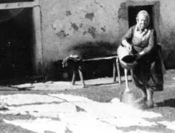

Tasks
- Find out about the various bleaching agents and draw up an overview of the bleaching agents you think would be suitable for inclusion in laundry detergents, and the ones which would not. Give reasons for your choices.
- After consulting your teacher, carry out experiments to show the effects of various bleaching agents.

²¹ Worksheet taken from: http://www.henkel.com/com/content_data/106612_4.8.2_Sustainable_washing_for_a_clean_environment_Chemistry_for_Advanced.pdf

Worksheet 10: The development of laundry detergents – from laboratory to production scale²²

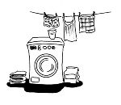
You work in the laboratory of a laundry detergent manufacturer. You would like to develop a new laundry detergent and you have to give your colleagues an overview of the properties your new product should have and what ingredients it should contain.

Tasks
- Decide first of all which type of laundry detergent you want to produce and what properties it should have (e.g. particularly good environmental compatibility, an attractive price, no fragrances, etc.). You can choose from three detergent types: heavy-duty detergents, detergents for colored fabrics, detergents for wool and silk.
- Material 1 contains standard compositions for the three laundry detergent types and Material 2 contains a choice of laundry detergent ingredients with their corresponding identification numbers (CAS no.). Use this material to gather information on the Internet about the criteria you have drawn up for the ingredients of your laundry detergent type and create a table.

The following Internet sites may be helpful:
- Wikipedia Encyclopedia http://en.wikipedia.org/wiki/Main_Page
- Database on hazardous substances http://www.dguv.de/bgia/en/gestis/index.jsp
- Costumer information on cleaning products http://uk.cleanright.eu/
- Raw material prices, e.g. Sigma-Aldrich www.sigmaaldrich.com (Registration site)

- Briefly describe the characteristic ingredients your laundry detergent should have. Remember that industrial production is a very large-scale operation. Give reasons for your decision. Also relate briefly whether there are any ingredients that should NOT be in the laundry detergent you develop.
²² Worksheet and relating Materials 1-2 are taken from: http://www.henkel.com/com/content_data/106612_4.8.2_Sustainable_washing_for_a_clean_environment_Chemistry_for_Advanced.pdf

Material 1
Standard compositions of laundry detergents

Laundry detergents | Ingredients  < 5% | Ingredients  5% to 15% | Ingredients  15% to 30% | Ingredients  > 30% | Other ingredients
Heavy-duty laundry detergents | Nonionic surfactants  Soap  Polycarboxylates  Phosphonates  Aliphatic hydrocarbons | Anionic surfactants | Oxygen-based bleaching agents  Zeolites |  | Enzymes (cellulase, lipase, protease)  Optical brighteners  Fragrances
Detergents for colored fabrics | Soap  Polycarboxylates  Phosphonates | Nonionic surfactants | Anionic surfactants | Zeolites | Enzymes (cellulase, lipase, protease)  Fragrances  Dye transfer inhibitors
Laundry detergents for wool and silk | Soap  Polycarboxylates  Nonionic surfactants | Anionic surfactants  Zeolites |  |  | Care Balsam  Fragrances  Auxiliaries  Dye transfer inhibitors

Material 2
NAME OF THE LAUNDRY DETERGENT INGREDIENT | CAS NO.
Washing active substances
Anionic surfactants
Soap | 8052-48-0
Linear alkylbenzene sulfonates (LAS) | 27176-87-0
Branched alkylbenzene sulfonates (TPS) | 11067-82-6
-Olefin sulfonates
Nonionic surfactants
Alcohol alkoxylates (EO/PO) | 69013-18-9
Alkyl polyglycosides (APG)
Softeners/Builders
Soda ash (Na₂CO₃) | 497-19-8
Nitrilotriacetic acid (NTA) | 139-13-9
EDTA | 60-00-4
Sodium tripolyphosphate | 7758-29-4
Zeolite A | 1318-02-1
Polycarboxylates
Phosphonates, e.g. HEDP | 2809-21-4
Bleaching agents
Sodium hypochlorite | 7681-52-9
N,N,N’,N’-Tetraacetylethylene diamine (TAED) | 10543-57-4
Sodium perborate | 7632-04-4
Sodium percarbonate | 15630-89-4
Enzymes, e.g. lipase, protease and cellulase
Foam regulators
Fatty acid amides | 124-26-5
Cocoamidopropyl betaine | 61789-40-0
Optical brighteners
Stilben derivatives | 16090-02-1
Naphthalene benzoxazoles | 5089-22-5
Perfumes
Sandalwood oil | 8006-87-9
Linalool | 78-70-6
Citronellol | 106-22-9
Musk xylene | 81-15-2
Dye transfer inhibitors, e.g. polyvinylpyrrolidone PVP | 9003-39-8
Antisoiling agents, e.g. PET/POET polymers
Antiredeposition agents, e.g. carboxymethyl cellulose | 9000-11-7
Fillers, e.g. Na₂SO₄ | 7757-82-6
Colorants
Corrosion inhibitors, e.g. sodium silicate (Na₂SiO₃) | 6834-92-0

Worksheet 11: Behavior of fibres during washing process

- Look at the following pictures (same fibre with different enlargements, taken by Kirsten Fischmann at Henkel facility) and comment on them.

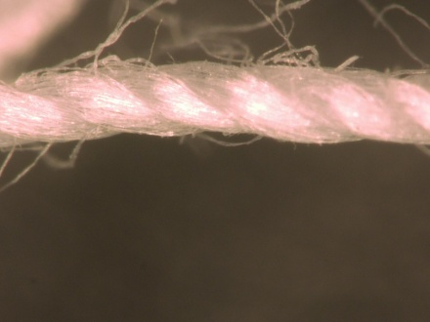  Cotton fibre | 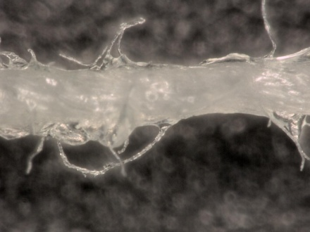  Cotton fibre with Persil Gold Universal Gel | 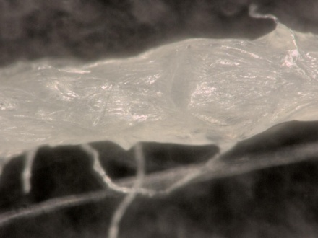  Cotton fibre with Persil Gold Universal Gel

- Reserach in school textbooks or on the internet, how dirt is removed from fabric on a submicroscopic level.
- Carry out the experiment as described in Worksheet 11a.

Worksheet 11a: Behaviour of fibres/textiles in the washing process

Apparatus and materials
- petri dishes and small beakers or yoghurt cup (depends on the number of laundry detergents and the concentration of solutions you like to test)
- pipettes and spatula (one for every detergent, depends on the viscosity)
- pieces of cloth/ threads of different fibres (wool, cotton, polyester, polyamide, viscose); multiplied by the number of detergent (and concentration, if you want to test several)
- tap water
- different laundry detergents (e.g. Persil-Universal-Powder; Persi-Universal-Gel; Perwoll-care for fine fabrics; Persil-Color-Gel; Perwoll-Powder for Wool and Silk; citric acid; washing soap)
- beakers to mix detergent and water
- pH meter
- stop watch
- scissors
- pair of tweezers
- microscope
- heating panel
- glass rod for stirring

Safety
- Wear your safety goggles!

Procedure
- Measure the pH value of tap water and each laundry detergent and solution.
- Prepare solutions of water and laundry detergent in beakers. Prepare solutions of different concentrations for each detergent. (for example, in one beaker add 50 g or 50 ml of the laundry detergent and about 250 ml of tap water and in another beaker prepare a higher concentration the laundry detergent) Label the beakers with name of detergent and concentration.
- Measure the pH value of each laundry detergent solution.
- Fill each solution in X (X = number of textile samples) petri dishes or small beakers.
- Then add a tiny piece of cloth and/or some fibres in one petri dish.
- Heat the solution up to 60°C on heating panels and stir the solution to simulate the washing process.
- Analyse the fibres after 5, 30, and 60 minutes under the microscope.

Disposal
- Take the pieces of cloth/ some fibres/threads out of the petri dishes with a pair of tweezers and put them into the dustbin.
- As these are solutions of laundry detergents, pour them down the sink.

Tasks:
- Carry out the experiments in teams.
- Fill in the table in Material 3 with a description of how the fibres look under the microscope.

Material 3: Analysis of cloth/fibre samples in different washing solutions
Detergent | soaking time and temperature | concentration | pH value | natural fibres |  |  | synthetic fibres
 |  |  |  | wool | cotton |  | polyester | polyamide | viscose
 |  | I II | I II | I II | I II |  | I II | I II | I II
all-purpose detergent | 5 min.
 | 30 min.
 | 60 min.
mild detergent | 5 min.
 | 30 min.
 | 60 min.
detergent for bright colours | 5 min.
 | 30 min.
 | 60 min.
special detergent: for woollen fabrics | 5 min.
 | 30 min.
 | 60 min.
washing soap | 5 min.
 | 30 min.
 | 60 min.
citric acid | 5 min.
 | 30 min.
 | 60 min.

Material 3: Possible solution - Analysis of the fibre samples in different washing solutions
 |  |  |  | Describe how the fibre look like under the microscope:
 |  |  |  | natural fibres |  | synthetic fibre
Laundry detergent | soaking time and temperature | concentration (detergent in g or ml / H₂0 in ml) | pH value | wool | cotton | polyester
All-purpose detergent  - Persil-Universal-Powder | 90 min.  40°C | 5 g in 100 ml H₂0 | 10,74 | 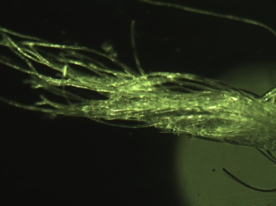 | 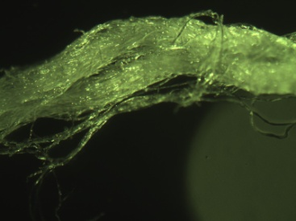 | 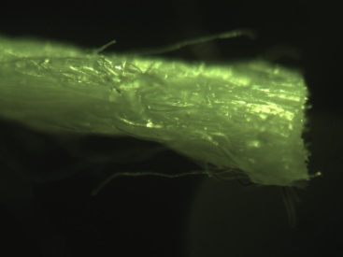
Mild detergent  - Perwoll – care for fine fabrics (liquid) | 110 min.  40°C | 5 ml in 250 ml H₂0 | 7,97 | 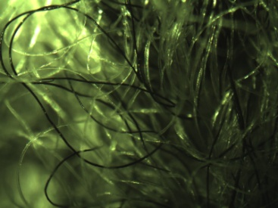 | 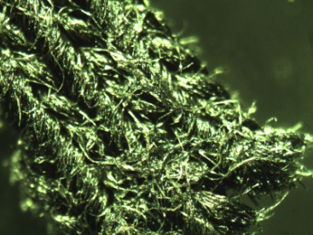 | 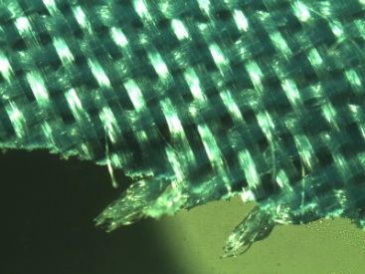
soapsuds  - e.g. Fa Bar Soap Vitalizing Aqua | 180 min.  40°C | 3 g in 250 ml H₂0 | 9,33 | 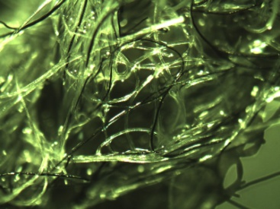 | 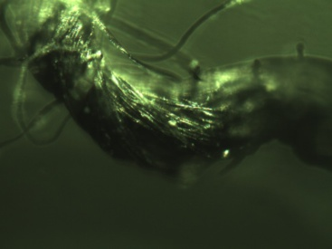 | 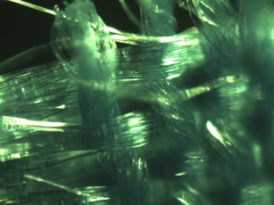
 |  |  |  | Describe how the fibre look like under the microscope:
 |  |  |  | natural fibres |  | synthetic fibre
 |  |  |  | wool | cotton | polyester
- washing soda | 180 min.  40°C | 2 EL in 250 ml H₂0 | 11,26 | 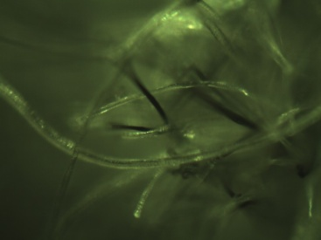 | 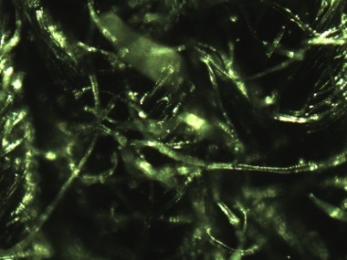 | 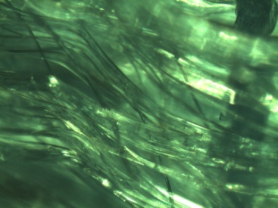
acidic solution  - vinegar cleaner | 180 min.  40°C | 5 ml in 250 ml H₂0 | 3,75 | 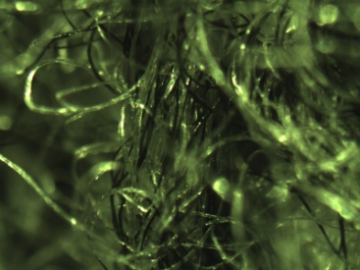 | 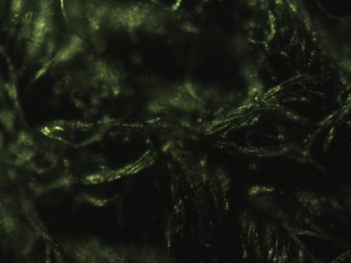 | 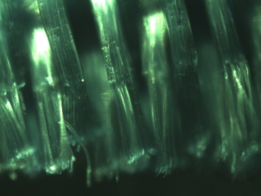

Material 4: Differences between laundry detergents
 | all-purpose detergent (solid/ powder) | all-purpose detergent (liquid) | mild detergent | detergent for bright colors | detergent for special fabrics  e.g. detergent for wool and silk | fabric softener
examples of Henkel AG & Co. KGaA products | Persil Universal, Weißer Riese, Spee als Pulver,  Megaperls®, Tabs |  | Persil, Weißer Riese, Spee als Gel, Spee Feinwäsche,  Perwoll Black für Schwarzes und Dunkles, Perwoll Sport für Synthetics | Persil Color, Weißer Riese Color, Spee Color als Pulver,  Megaperls®, Tabs, Gel | Perwoll Wolle & Seide  Perwoll Pflege für Feines (liquid)* | Vernel
anionic surfactants
non-ionic surfactants
cationic surfactants |  |  |  | ()
softener
bleaching agent
enzymes
optical brighteners

²³ Sources:
- http://dblay.de/einblicke/wasch/arten
- Richtig Waschen: Informationen rund ums Waschen – Spülen – Reinigen. Jens Gebhard, Christa Wolf, Kerstin Ochs. Henkel AG & Co. KGaA. Redaktion: Consumer Relations. Düsseldorf, 2008. http://www.henkel.de/de/content_data/95757_richtigwaschen_080723.pdf
- (Flyer) Textilien richtig waschen – Werte erhalten. Forum Waschen c/o. Industrieverband Körperpflege- und Waschmittel e.V. (IKW). Frankfurt am Main. 2011. http://www.ikw.org/pdf/broschueren/IKW_FB_RichtigWaschen_web.pdf

