Kinds of plastic packages and their labelling

Student’s worksheet
You can come across plastic packages at every place. Producers label products packages with names and symbols of used kind of plastic or the information is stamped (most frequently in the bottom part of a package). The following materials are used, for example: polyethylene terephthalate, polyethylene, polypropylene, polyvinyl chloride, polystyrene.

Written labelling of plastic materials:

Material | Number labelling | Letter labelling
Polyethylene terephthalate | 1 | PET
High density Polyethylene | 2 | HDPE
Polyvinyl chloride | 3 | PVC
Low density Polyethylene | 4 | LDPE
Polypropylene | 5 | PP
Polystyrene | 6 | PS

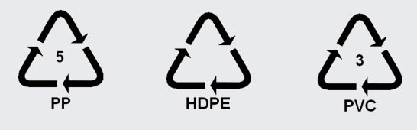
Graphic labelling of plastic materials:

Task 1
1. There are plastic packages made of four different kinds of plastic in the pictures. Below each of the pictures write the name of the plastic the package is made of.
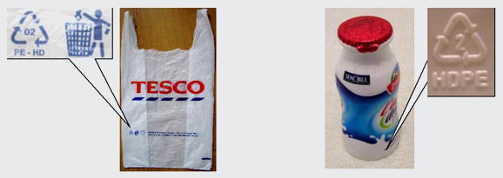

1)........................................................ 2) ........................................................

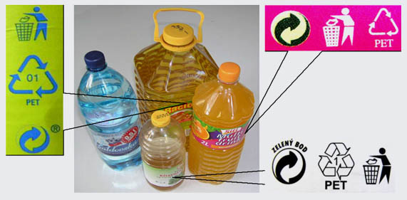

3) .......................................................... 4) ........................................................

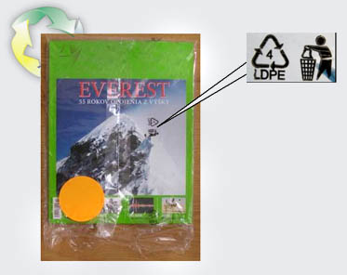

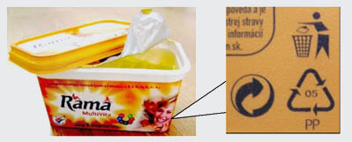

5) .......................................................... 6) .........................................................

Task 2

Answer the following questions:

What is the significance of packaging plastic?
..............................................................................................................................................................................................................................................................................................................

Compare different properties of natural and plastic materials.
..............................................................................................................................................................................................................................................................................................................

