Activity 2.1 Membranes with invisible holes - worksheet Page 1of 2

- Set up the experiment as advised. Put in the labels on each tube.
1
2
3
4

Observations:
 |  | 1 | 2 | 3 | 4
Colour at start | In small bag
Colour at start | In tube
Colour at end | In small bag
Colour at end | In tube

- Can you explain what is happening?
………………………………………………………………………………………………………………………………………………………………………………………………………………………………………………………………………………………………………………………………………………………………………………………………………………………………………………………………………………………………………………………………
Activity 2.1 Membranes with invisible holes - worksheet Page 2 of 2

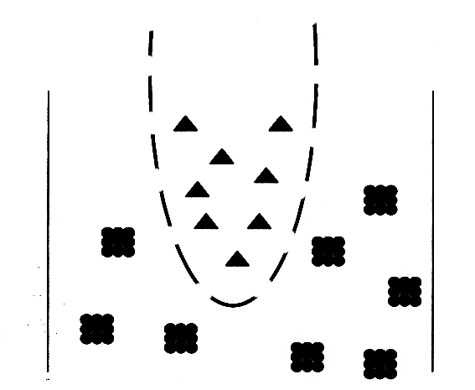
3. Can you match each tube of your experiment to one of these diagrams?
C
A
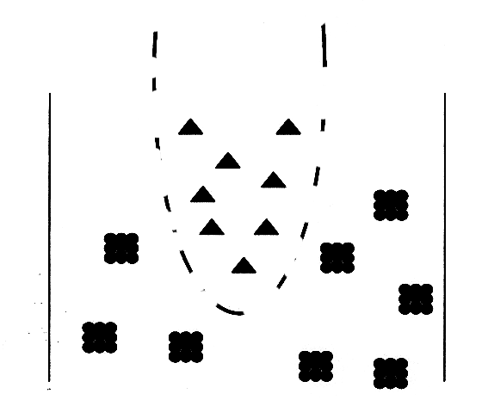
A

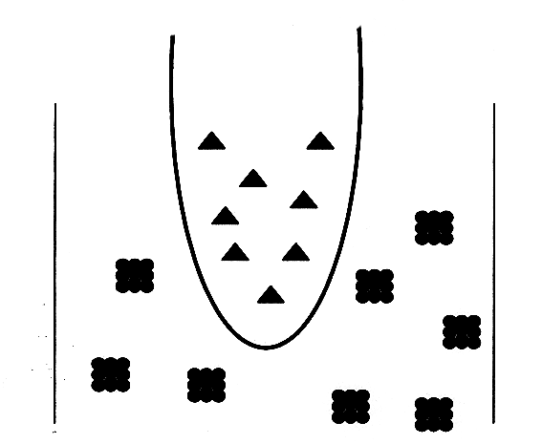
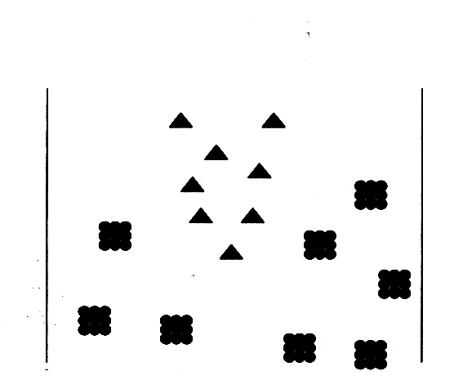
D
B

4. What would happen in each tube if the solutions were reversed- if the solution of smaller molecules was in the tube and the solution of larger molecules in the membrane at the start?
