2. Do muscle, fat and bone sound the same?
- Imagine a woman in early pregnancy. She needs to have an accurate dating of the pregnancy so as to estimate the birth date of her baby and to help assess proper growth during the pregnancy. Can we also use sound to “see” inside ourselves?

- Let us first consider the question when an echo occurs?
Consider a person standing outside in an open field, clapping his hands. Does he hear the echo of the sound clap? Explain what happens.

- Now consider a person standing outside in front of a high wall. When he claps in his hands, does he hear an echo now? Explain what happens.

Complete the following sentence:

I think the echo is: ____________________________________________________

Describe another place in which you would expect to hear echoes.

- An echo is the result of a sound reflecting from an object made from a material different than air. A fancy word for such object is a reflection interface, which means an abrupt change in the material carrying sound wave (air – brick wall).

- Does the strength of the reflection, or echo, depend on the material, which reflects sound? Write down your hypothesis:

You are going to check your hypothesis in an experiment in which you will compare two reflection materials: a hard material (e.g. piece of wood, hard plastic, hard book, etc.) and a soft material (e.g. polyurethane foam, sponge, etc.).
You will perform the experiment with computer with a sound sensor and a hollow cartoon tube.

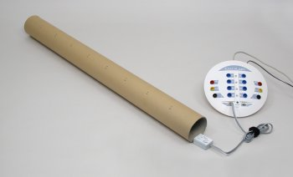
- Connect the sound sensor to your data-logger.
- Start the Coach activity “Reflection interface”.
- Close one end of the tube with a hard material (inserting a plastic plug or placing a book against the end).
- Place the sound sensor at the opening of the tube. Position it so that it can detect the initial sound and the echo coming back down the tube.
- Snap your fingers near the opening to create the initial sound. The sound should be loud and sharp.
- In the Coach activity the recording is triggered. After clicking the Start button the computer will wait until it detects your initial sound. Then the measurement is automatically started.
- Repeat the experiment for soft material. Try to snap your fingers in the same way so the intensity of sound will be the same.

- Which material reflects better sound waves? How do you know? Give evidence for this.

Describe the properties of the material which reflects sound well.

Describe the properties of material which reflects sound badly.

- Consider a person standing outside in front of a high wall, clapping in his hands. Imagine you stay at the other site of the wall with your ear close to the wall (close your other ear with your hand). Do you think you can hear the sound of the clap? You can try this experiment in the class. Describe your findings.

- When sound waves meet reflection interface they are partly reflected (echo) and partly transmitted through the interface and propagate in a new medium (so you can hear sound in the wall).
Does sound travel with the same speed in different media? Write down your hypothesis:

You are going to check this in an experiment in which you will compare the speed of waves in water an in vegetable oil. Instead of sound waves you will use mechanical waves because these waves are easier to visualize.
To perform this investigation you have the following materials available: 2 ripple tanks, water, vegetable oil, 2 plastic droppers, a metric ruler and a stopwatch.
- Study the materials provided and think how you could use them to compare the speed of waves in water and in vegetable oil.
- Write a brief description of the experiment you plan to perform. Consider which variables should be kept constant and which variables change. Discuss your plan with teacher before you proceed.

- Conduct your experiment and record your data below. You should conduct a few trials of each experiment and average the results.

Water | Vegetable oil

- Through which medium, water or vegetable oil, do waves travel faster?

- What average speed did you calculate for each medium?

- You have learned that sound can reflect from a reflection interface, can be transmitted through a medium and propagates with different speeds in different media. These properties of sound are used to see “inside” us. Doctors use ultrasound to see inside a patient’s body.

Different human body tissues such as fat, muscle and many body organs are made from a little bit different materials, with different densities, elastic properties and sound speed. Each change of human tissue acts like a reflection interface.
- Look at the figure below and describe how do you think this works.
Notice that ultrasound pulses are produced and detected by ultrasound transducer. You will learn more about it in next lessons.

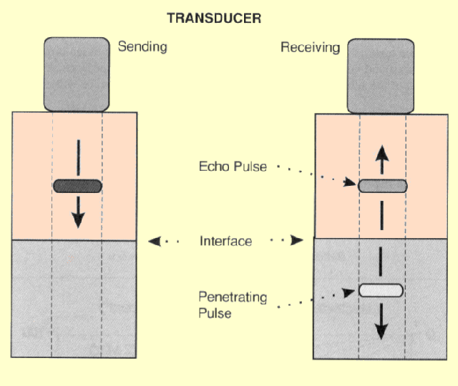

- To describe the acoustic properties of a medium such as a human body tissue, the term acoustic impedance is used. Acoustic impedance is the resistance that a sound wave encounters as it passes through a medium. It depends on the density of the medium and the speed of sound in the medium. Slight differences in acoustic impedance between two media (tissues) create a reflection interface that will cause the ultrasound wave to be reflected. The greater the difference in tissue impedances, the more sound will be reflected rather than transmitted into the medium.

Some typical impedances of human tissues are:

Medium | Impedance (in standard unit)
Air | 0.0004
Fat | 1.33
Water | 1.48
Blood | 1.66
Kidney | 1.62
Liver | 1.66
Muscle | 1.65-1.74
Bone | 7.8

