## 2. Interaction with matter

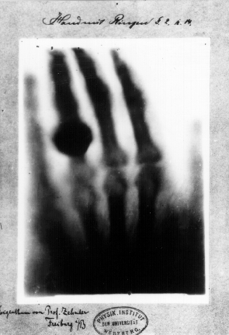

1. The photo at the right shows the very first X-ray image made of a human body, it is the left hand of Mr Roentgen’s wife, including her wedding ring!

In fact, within one month after the discovery of X-rays, two French physicists had produced a photograph showing the bones in a human hand. Over the years the exceptional properties of X-rays have made them very useful in medicine. Probably you or somebody from your family has experienced such an examination.

The quality of modern X-ray images has improved a lot. Below you see two examples of modern X-ray images.

Describe what the images show.

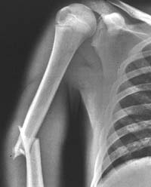 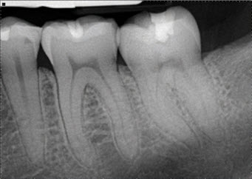

What do you think, explain:

* what are the dark areas on the photos?
* what are the light areas on the photos?
* which properties of X-rays make it possible to get such images?
* how do X-rays interact with matter?

1. As you can see from the X-ray images, a part of the X-ray photons passes through the human body. These photons generate grey shaded X-ray images. Another part of X-ray photons interacts with human tissues and is absorbed in a process known as attenuation.[1] Bones and tooth fillings absorb X-rays very well – this is shown as the white areas in the images, while soft tissues do not stop X-rays so well and these appear grey in images. The air around the patient hardly stops any x-rays and appears black.

Now you are going to investigate the process of attenuation. In your investigation you will use gamma rays instead of X-rays because the sources of this radiation are much easier to get. Gamma rays are actually very similar to X-rays, they are both types of electromagnetic radiation and the difference is that gamma rays have shorter wavelengths and more energy than X-rays. Gamma rays interact with matter in a similar way as X-rays do.

Your research questions are:

1. How does the degree of absorption depend on the type of material?
2. How does the degree of absorption depend on the thickness of the absorbing material?

In your investigation you will use the following materials:

* gamma source e.g. Cobalt-60
* a device to detect the radiation e.g. a Geiger- Müller counter or a radiation sensor with a data-logger and software (Coach 6)
* a set of absorption plates of the same thickness made from different materials e.g. Plexiglas, aluminium, steel, lead.
* a set of absorption plates of the same thickness, made from lead.
* Design experiments to answer the research questions.
* Collect data.
* Answer your research questions. Use the evidence obtained in your experiments.
* Which material is the best absorber?
* Determine the mathematical function, which best describes the relationship between the intensity of the radiation and the thickness of the lead absorber.
* What is the thickness of lead for which the radiation is reduced to 50% of the original radiation?
* What would you expect if you would use X-rays in this experiment?

1. X-rays, similar to gamma rays, are attenuated as they pass through matter. That is, the intensity of an X-ray beam decreases the farther it penetrates into matter.

The law of attenuation is expressed as follows: Let us assume that the primary beam consists of photons of a single X-ray energy, and that no scattering occurs. Then

I=I0*e- µx

where

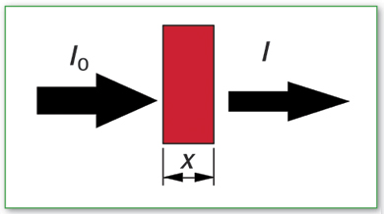  
I0 - the initial intensity of X-rays

I - the intensity of X-rays after penetrating through matter

x - thickness of matter

µ - linear attenuation coefficient

The *linear attenuation coefficient* µ describes the fraction of incident X-rays or gamma rays that is absorbed per unit thickness of the absorber (unit: 1/length).

Thus a value of μ=0.01 cm-1 implies that ~1% of X-ray photons incident on an absorber of thickness 1 cm will be attenuated and 99% will be transmitted through. When μ increases to 0.5 cm-1 for an absorber of the same thickness, the transmission is ≈ 60% (i.e. e-0.5) and the attenuation provided is therefore ≈ 40%.

Since the linear attenuation coefficient is dependent on the density ρ of the material, the *mass attenuation coefficient* μm = μ/ρ (cm2/g) can be used to compare the absorbing abilities among different materials.

A useful practical parameter can be derived from the linear attenuation coefficient called the *Half Value Layer* (HVL). The HVL is the thickness which absorbs half the amount of the incident X-rays. Since

I=I0*e- µx  if I/I0 = ½ then e- µx = ½ then

HVL = ln (2/μ) = 0.693/μ

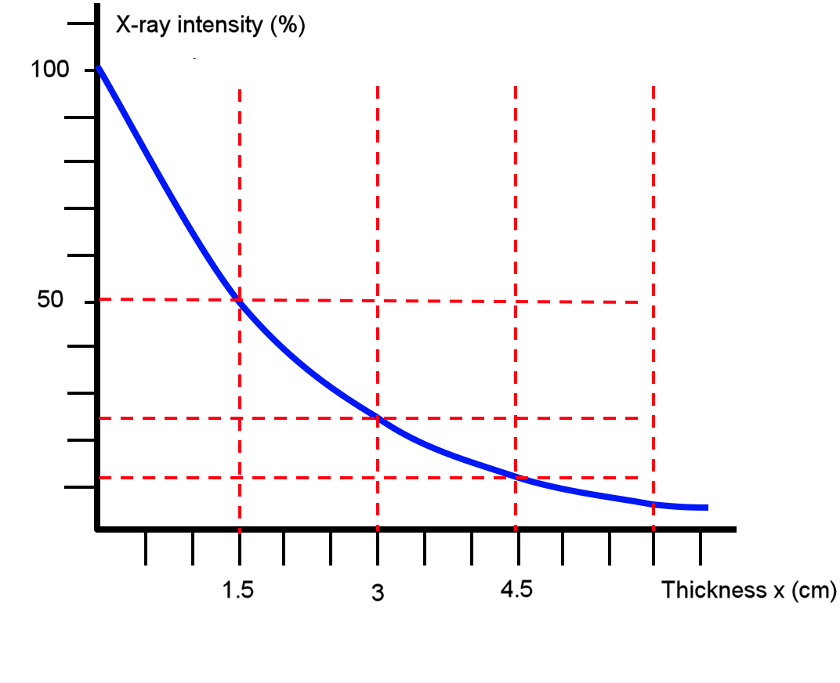The graph shows attenuation of X-ray radiation of one energy value.

* Look at the graph and determine the HVL.
* What percentage of the initial X-ray intensity will penetrate to a depth of   
  3 cm, 4.5 and 6 cm?
* How do you think this graph will look for X-rays with a higher energy level?

1. Now you will compare the mass attenuation coefficients and HVLs for various human tissues.

Below you see a graph mass attenuation coefficients for bone and soft tissue against energy of X-rays photons.

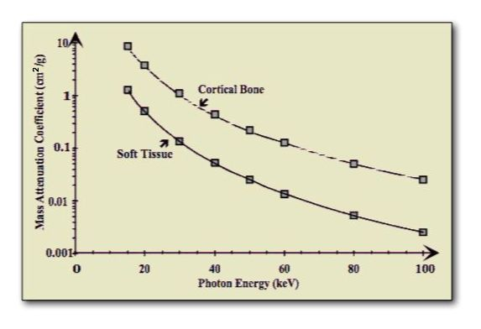

* Compare the mass attenuation coefficients for bone and soft tissue. Which material absorb X-rays better?
* How does the value of the mass attenuation coefficient change when the energy of the X-rays increases? Explain, what this means in terms of absorption and penetration of the X-rays?
* Assume that the linear attenuation coefficients for bone and soft tissue have the following values:

|  |  |  |
| --- | --- | --- |
| **Material** | **30 keV** | **60 keV** |
| Bone | 1.6 cm-1 | 0.45 cm-1 |
| Soft Tissue | 0.38 cm-1 | 0.21 cm-1 |

Calculate the HVL values of bone and soft tissue for both X-rays energies, 30 keV and 60 keV.

* Which material absorbs X-rays better: material with a large HLV or material with a small HLV.
* How do you think how the HVL changes when the energy of the X-rays increases?

In a normal X-ray image, most soft tissue does not show up clearly. To focus in on organs, or to examine the blood vessels that make up the circulatory system, doctors must inject **contrast media** into the body. Contrast media are liquids that absorb X-rays more effectively than the surrounding tissue.   
To bring organs in the digestive and endocrine systems into focus, a patient will swallow a contrast media solution.   
If the doctors want to examine blood vessels or other elements in the circulatory system, they will inject contrast media into the patient's bloodstream.

1. There is a third part of X-ray photons, which are scattered. Scattering involves a partial transfer of energy to tissue, with the resulting scattered X-rays having less energy and a different trajectory. This interaction does not provide any useful information (degrades image quality) and is the primary source of radiation exposure to staff.