4. CT scans

- X-ray machines are very useful but they take flat, two-dimensional images. In many medical situation this is enough but in some not.

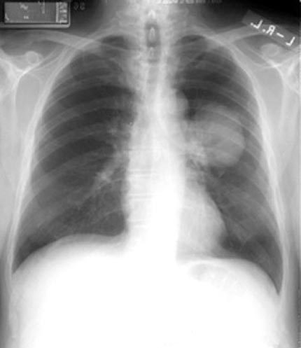
On the photo you see a frontal X-ray scan of a chest. This photo demonstrates a cancer on the left lung.

- Can you indicate the place where the tumour is located? How do you know?
- Can you see how deep the tumour is?
- What would be needed to be able to better locate the tumour?
- Do you have any idea how we could take an X-ray scan of a slice of the body?

- If a larger bone is directly between the X-ray machine and a smaller bone, the larger bone may cover the smaller bone on the image.
What would you have to do in order to see the smaller bone?

- What an X-ray scan shows is a flat shadow image showing all body parts across the body in the direction where the scan was taken (on the chest photo: ribs, lungs, tumour). On such an image all information about depth is lost.
X-ray photons have the same nature as visible light photons, but they have much more energy. A conventional X-ray image is basically a shadow: you shine a "light" on one side of the body, and a detector on the other side registers the silhouette of the bones. However shadows give you an incomplete picture of an object's shape.
Imagine you are standing in a room corner, in front of a wall, holding a pineapple against your chest with your right hand and a banana out to your side with your left hand. Your friend is looking only at the wall, not at you.

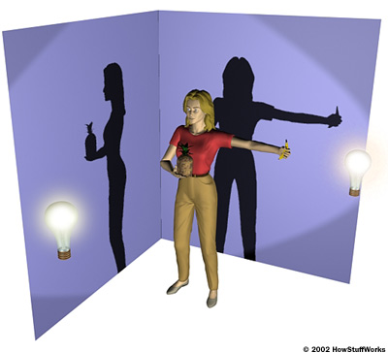

- What will your friend see when a lamp in front of you is turned on? Can he see that you hold a banana and a pineapple?
- What will your friend see when a lamp at your left side is turned on? Can he see that you hold a banana and a pineapple?
- What will your friend see when both lamps are turned on? Can he see that you hold a banana and a pineapple?

- In order to know that you are holding a pineapple and a banana, your friend would have to see your shadow in both positions and form a complete mental image. This is the basic idea of computer tomography (CT).

Now you will "scan" an object using an “virtual” X-ray beam and a model of a rib cage. You will use the simulation available at:
http://www.colorado.edu/physics/2000/tomography/final_rib_cage.html.
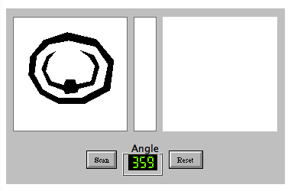
- Scan the model of a rib cage. The X-ray beam comes from the left, the scanned image is shown in the right window.
Press the "Scan" button to make a single scan. Now click and drag the figure on the left to turn it. Press "Scan" again...this time the new scan gets averaged into the previous one. Continue to turn and scan until you get a good scan.
- Draw your final scan in the empty space above.
- How can you improve the quality of your scan?

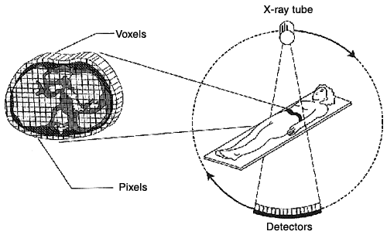
Computed tomography (CT) allows producing an image of a slice of the body and uses computers to generate a three-dimensional image from two-dimensional X-ray slice images.
In the simulation you have turned the scanned object around and the X-ray beam was not moving.
In a real CT scan machine the X-ray beam moves all around the patient, scanning from hundreds of different angles.
Image: http://www.physicscentral.org/explore/action/scans-1.cfm
- In modern CT scan machines the patient lies down on a platform, which slowly moves through the hole in the machine. The X-ray tube is mounted on a movable ring around the edges of the hole. The ring also supports an array of X-ray detectors directly opposite the X-ray tube. A motor turns the ring so that the X-ray tube and the X-ray detectors revolve around the body. Each full revolution scans a narrow, horizontal "slice" of the body. The control system moves the platform further into the hole so the tube and detectors can scan the next slice. In this way, the machine records X-ray slices across the body in a spiral motion. The computer varies the intensity of the X-rays in order to scan each type of tissue with the optimum power. After the patient passes through the machine, the computer combines all information from each scan to form a detailed image of the body.
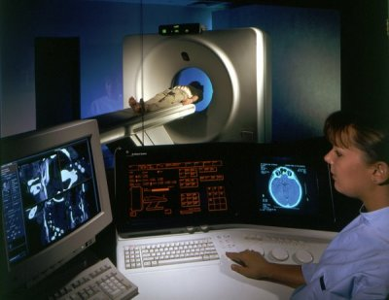
CT scan machine
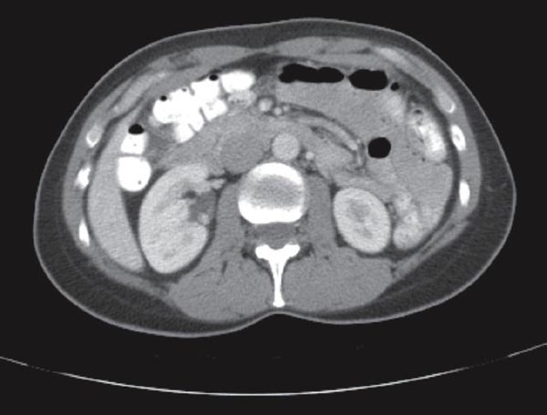
CT scan showing cross section of abdomen

- Watch the movie ‘Analog Slices’
http://videos.howstuffworks.com/discovery/45162-the-ge-show-presents-analog-slices-video.htm. This film shows the idea of computer tomography, using everything from horned melons to violins and hairdryers.

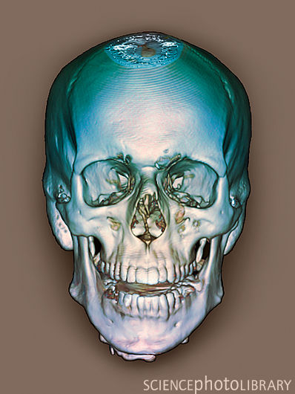
Modern, coloured 3D CT scan of the healthy skull

- Watch the YouTube movie ‘CT Scans How it works’ http://www.youtube.com/watch?v=rN4E8Y5loAs&feature=related.
- Explain in your own words the principle of the CT scan machine.

