1. α, β, and γ

- Shortly after the discovery of X-rays, the French scientist Henri Becquerel tried to find out whether any elements spontaneously emit X-rays.

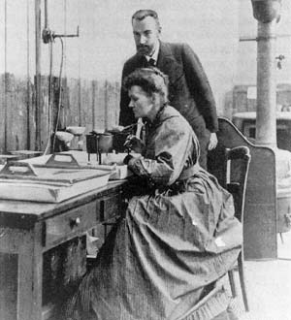
Becquerel was conducting experiments, which started with the exposure of a uranium-bearing crystal to sunlight. Once the crystal had v=been in the sunshine for a while, he placed it on a photographic plate. On a cloudy day he put his wrapped photographic plates away in a darkened drawer, along with some crystals containing uranium. When the weather had cleared, he returned to the drawer to retrieve his sample. He was surprised to find that the crystal had left a clear, strong image on the photographic plate. How could this be? There was no source of energy to produce the image - the uranium crystals emitted rays on their own!
The husband and wife team of Pierre and Marie Curie (shown on the photo) became interested in Becquerel’s discovery. They came up with the term "radioactivity" to describe the spontaneous emissions that they studied. Their observations led to the discovery of two new radioactive elements, which they named polonium and radium. In 1903, Becquerel and the Curies together received the Nobel Prize in physics. This award was for their discovery of radioactivity and their other contributions in this area. Marie Curie received a second Nobel Prize in 1911 for the discovery of polonium and radium. She was the first person to win two Nobel Prizes!

- In activity 2 of subunit 2 you have already learned about other radiation different than X-rays. You have used gamma rays instead of X-rays. Gamma rays are very similar to X-rays, they are both electromagnetic radiation type but gamma rays are produced by natural materials.
Compare these two radiation; the table below may help you with it, but you need to complete it first:
Property | X-rays | gamma rays
Photons | produced by accelerated electrons hitting a tungsten | emitted from the nucleus in a process of natural radiation
Energy carried by photons
Wave length
Speed of photons

- Describe in your own words what the similarities and differences are between X-ray and gamma radiation.

- Gamma radiation is electromagnetic radiation. Photons of high energy are emitted when a nucleus changes from higher energy state to a lower energy state. There is another natural type of radiation that is emitted from the nucleus and that carries energy similar to the energy of gamma rays. In this radiation Alpha and Beta particles are emitted from the nucleus.

An insight into the properties of nuclear radiation can be obtained by observing its behaviour in an electric and magnetic field. The pictures below show the behaviour of different types of radiation in an electric field (top) and a magnetic field (bottom).
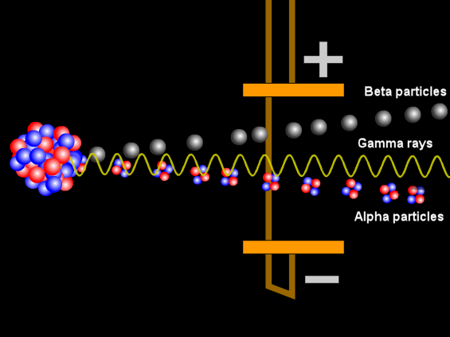
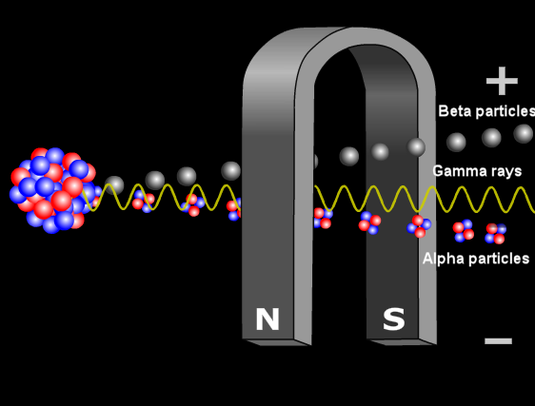
Images:
animation at http://www.passmyexams.co.uk/GCSE/physics/properties-of-radiation-electric-magnetic-field.html

- How do the three types of radiation behave in an electric field?
- How do the three types of radiation behave in a magnetic field?
- What is your hypothesis about the charge associated with different types of radiation? Explain how do you know.
- What is your hypothesis about the mass of different radiations? Explain how do you concluded.

After being emitted from a decaying nucleus, the alpha, beta or gamma radiation may pass through matter. Now you are going to compare the penetrating powers of these types of radiation.
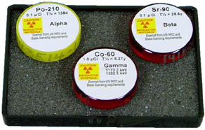
You have the following materials available:
- Radiation sources:
Alpha source (e.g. Po-210),
Beta source (e.g. Sr-90) and
Gamma source (e.g. Co-60)
- A detection device: a Geiger- Müller counter or a radiation sensor with a data-logger and software (Coach 6)
- A set of absorbers (e.g. paper, aluminium and lead of varying thicknesses, wood).
Follow all local safety procedures for handling radioactive materials.

- Design an experiment to investigate the range and penetrating properties of each type of radiation.
- Complete the sentences:
Alpha radiation is stopped by: _______________________________________
Beta radiation is stopped by: ________________________________________
Gamma radiation is stopped by: ______________________________________
- Which radiation type does interact more strongly with matter? How do you know?
- Which radiation type has the longest range? How do you know?

- All elements of with an atomic number greater than 82 (lead) are radioactive. These elements can emit three distinct types of nuclear radiation, α, β, and γ. These types of radiation are the result of changes occurring with the central atomic core – the nucleus.

α radiation consists of a stream of fast-moving alpha particles. An α particle is a helium nucleus and consists of two protons and two neutrons with an atomic mass of 4. As such, an alpha particle is relatively heavy and carries two positive electrical charges.
Alpha decay only occurs in very heavy elements such as uranium, thorium and radium. The nuclei of these atoms are very "neutron rich" (i.e. have a lot more neutrons in their nucleus than protons) which makes emission of alpha particles possible.

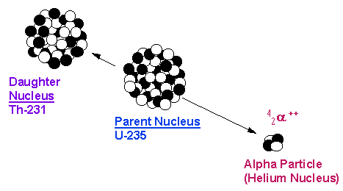

β radiation consists of fast-moving electrons. A β particle is much lighter than an alpha, and carries one unit of negative charge. Like alpha decay, beta decay occurs in isotopes, which are "neutron rich" (i.e. have a lot more neutrons in their nucleus than protons).

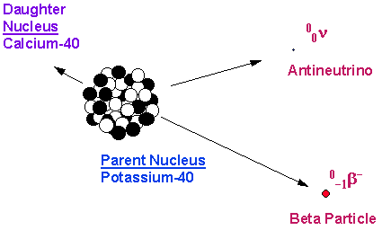

γ radiation consists of photons, which are massless and carry no charge. After a decay event, the nucleus is often in an excited state. This means that the decay resulted in producing a nucleus, which still has excess energy to get rid of. Rather than emitting another beta or alpha particle, this energy is lost by emitting a pulse of electromagnetic radiation called a gamma ray. The gamma ray is identical in nature to light or microwaves, but of very high energy.
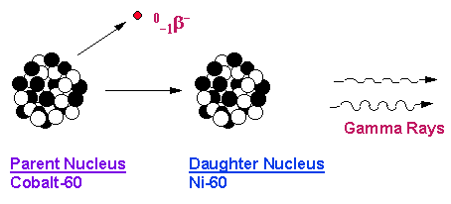
It is important to note that most alpha and beta emitters also emit gamma rays as part of their decay process.
Alpha particles are high energy, relatively heavy structures. They can travel only a short distance and are stopped by a piece of paper or skin.
Beta particles are fast moving electrons. They are a fraction of the size of alpha particles, can travel farther and are more penetrating.
Gamma radiation has a higher penetration power than alpha and beta radiation.

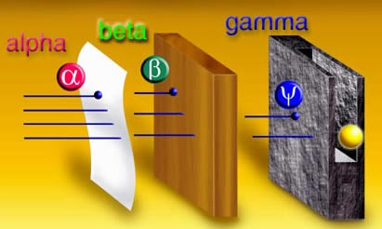
Image: http://www.ndt-ed.org/EducationResources/CommunityCollege/RadiationSafety/theory/nature.htm

Ionization is a particular characteristic of the radiation produced when radioactive elements decay. These radiations are of such high energy that when they interact with materials, they can remove electrons from the atoms in it.
This effect is the reason why ionizing radiation is hazardous to health, and provides the means by which radiation can be detected. Issues related to ionizing radiation will be discussed in the next lessons.

- Watch a short animation about alpha, beta and gamma types of radiation. (penetration_anim.mov)

- In nuclear medicine radioactive materials are used to trace tumours.
A small amount of radioactive materials are introduced into the body. The radioactive material collects in fast growing areas like tumours. A special camera is then used to take images of the body.
Below you see an example of such image. To be able to make this image the radioactive material should emit gamma rays.

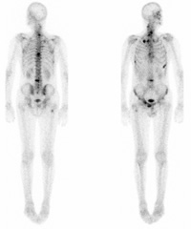

- What do you think what kind of radiation is emitted from the body?
- Explain why radioactive material that emits alpha or beta radiation is not suitable to make such scans.

