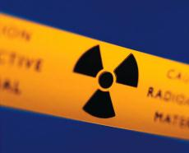
5. Radiation protection
  - Too much radiation can be harmful. But what is a “big” dose? You might say that a big dose is one that adds appreciably to the natural background dose.
Assume that you typically get a dose to 2 mSv each year from natural radiation sources. Then the dose equivalent to a dental X-ray, 0.02 mSv adds only 1% to the background, but the dose equivalent to a CT head scan, 2 mSv doubles the amount radiation you get. Before you decide about the CT scan you would like to know the risks incurred by such doses.
The risk of radiation exposure is estimated by ‘’International Commission on Radiological Protection’ (ICRP). The current official estimates of IRCP suggest that a person receiving a dose of one Sievert (similar to that received by the Japanese survivors of the atom bomb), will have an increased chance of eventually dying of cancer from about 25% (the “natural” cancer rate”) to about 30%. This is the probabilistic risk of a person dying from cancer and an extra risk of about 5% due to dose of one Sievert. That means that on average 5 out of 100 people develop a cancer from exposure to a dose equivalent to 1 Sv. But 1 Sv is a very large dose – 500 times the background.
For smaller doses one approach is simply to reduce the risk in proportion. The table below shows an example of making the calculation in this way from the risk from a dental X-ray.
Dose equivalent | Risk
1 Sv | 5% | Or 5 in 100
0.02 mSv | 5*0.02*10⁻³ % | Or 1 in 1 million

- Is this risk high?
The list below presents activities calculated to have a one-in-a-million chance of causing death.
  - Spending 2 days in New York City (because of the air quality)
  - Riding 1 mile on a motorcycle or 300 miles in a car (because of the risk of collision)
  - Eating 40 tablespoons of peanut butter or 10 charbroiled steaks (because of the risk of cancer)
  - Smoking 1 cigarette (because of the risk of cancer).
- What is the probability risk of a CT head scan?
- Would you accept such risk? How would you judge?

  - We should avoid exposure to high levels of ionising radiation because of the risk it carries. Unfortunately we cannot avoid the radiation completely because of natural radiation. However, we can and should minimise unnecessary exposure to significant levels of man-made radiation.

- How can the exposure to man-made radiation be minimized?

- Scientists and health care workers. who us intense radiation sources, are often told that the best protection is distance; that is, the best way to minimize exposure to radiation is to stay far away from the radiation source. Why is that?
How do you think does radiation intensity change when you get closer to the radiation source? Sketch your prediction in a graph of the radiation intensity versus distance from the source.

- Design and carry out an experiment to investigate how the radiation emitted by a radioactive source changes with the distance from the source.

- Draw your measurement result. Was your prediction correct?

- Determine the function that describes the relationship between the radiation intensity and distance from the source.

- In subunit 2 you have learned that gamma and X-rays can pass through matter but they are also absorbed.

- Write down the absorption law, which you have discovered for gamma rays (subunit 2, activity 2).
- Do you think this law is also valid for beta radiation?

- Test your hypothesis in the experiment with beta radiation. For absorption of beta radiation you can use ten small (e.g. 10 cm × 10 cm) identical cardboard squares or household aluminum foils.

- From the evidence presented in your graph, does the transmission of beta radiation through cardboard match the same absorption law?

- Can you test this law for alpha radiation? Explain why.

- List the ways to protect a person against ionizing radiation.

  - There are three factors that control the amount, or dose, of radiation received from a source. Radiation exposure can be managed by a combination of these factors.
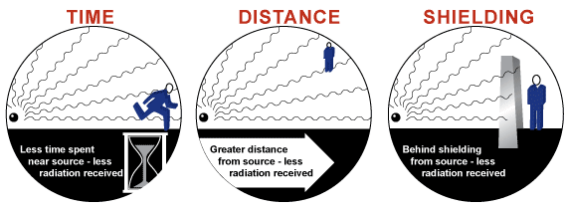

1. MINIMIZE EXPOSURE TIME
The radiation dose is directly proportional to the time spent in the radiation. Therefore, a person should not stay near a source of radiation any longer than necessary.

2. MAXIMIZE DISTANCE:
Increasing the distance from the source of radiation will reduce the amount of radiation received. This can be expressed by an equation known as the inverse square law, which states that as the radiation travels out from the source, the dosage decreases inversely with the square of the distance.
I ~ 1/x²
where x is a distance to the radiation source.
- How does the radiation intensity change when the distance from the radiation source is doubled?

3. USE SHIELDING
The third way to reduce exposure to radiation is to place something between the radiographer and the source of radiation. When a radiation passes through a material it is absorbed according to the absorption law:
I=I₀•e⁻ ^{µx}.
The intensity of radiation let through depends on the thickness of the shield and density of the used material.
- What are the most effective materials in shielding radiation?

Over the years numerous recommendations regarding the radiation safety have been developed. Current guidelines are based on the conservative assumption that there is no safe level of exposure. In other words, even the smallest exposure has some probability of causing a stochastic effect, such as cancer.
This assumption has led to the general ALARA philosophy of keeping all radiation exposure "As Low As Reasonable Achievable". It means that every reasonable effort must be made to keep the dose to workers and the public as far below the required limits as possible. This also describes the evaluation which medics have to conduct before supplying X-rays, or another treatment at which radiation is emmited. Medics have to consider whether or not the advantages outweigh the risks of inflicting radiation upon a person.

  - Health care staff involved in radiology or nuclear medicine would like to monitor their radiation exposure. For this purpose film badges are used.

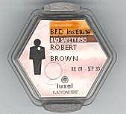

Film badge:
This is a passive dosimeter for personal exposure monitoring. It should be worn whenever working with X-ray equipment, radioactive patients or radioactive materials. Depending on the work circumstances, body badges may be worn at collar level, chest level or waist level.

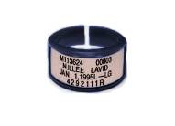

Ring badge:
Used for measuring beta and gamma doses to the hand. Should be worn on the hand, which is closest to the radiation source.

Origin: http://www.osha.gov/SLTC/etools/
hospital/clinical/radiology/radiology.html

- Find out and described how these badges work.

