Worksheet: Hearing sound

You know that sounds start with vibrating objects, which start sound waves in a medium (such as water, wood, or air). But to complete the sound story you need to know how do you hear the sound?

OBSERVATIONS
- Look at the picture and explain how you can hear sound.
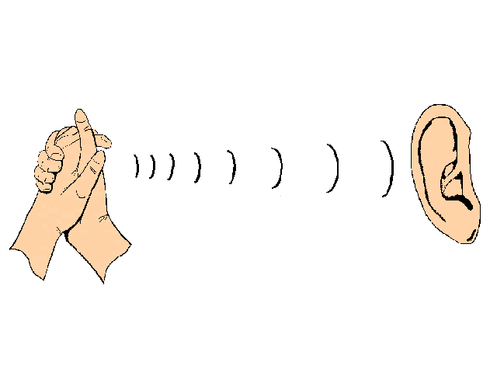

- What do you think is the purpose of your outer ear?

- Your eardrum is a piece of skin just like a stretched balloon. It vibrates when sounds reach your ear. Bones that touch the eardrum carry the vibrations to your inner ear, where they are detected and translated into signals to the brain. Here is a diagram of the ear.

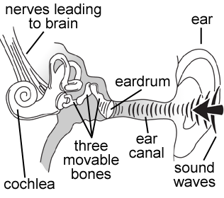
Questions to think about
- When a compression in a sound wave in the air hits the eardrum, in which direction does the eardrum move?
- In which direction does the eardrum moves when an expansion of a sound waves arises?
- If you hear a bird sing with a frequency of 2000 vibrations per second, how many times per second does the eardrum vibrates?
- How does the ear response to a loud sound differ from its response to a soft sound?
- How does the ear response to a high sound differ from its response to a low sound?
- Why sounds aren't as loud when you cover your ear?
- How does the ear strengthen the sound waves so that they will be strong enough to affect the liquid of the inner ear?

- Can we hear all sounds?
If you blow a dog whistle can you hear it? Do you know why?

The human ear typically can hear sounds from sources that vibrate as slowly as 20 vibrations per second (20 Hz) and rapidly as 20 000 vibrations per second. Any sound with frequency below the range of human hearing is known as infrasound; any sound with frequency above human hearing range is known as ultrasound. Many animals can hear frequencies of sound outside the range of human hearing, see the table below.

Animal | Hearing range
Dog | 40 Hz to 46 000 Hz
Rabbit | 360 Hz to 42 000 Hz
Cat | 45 Hz to 64 000 Hz
Cow | 23 Hz to 35 000 Hz
Mouse | 1000 Hz to 91 000 Hz
Bat | 2000 Hz to 110 000 Hz
Dolphin | 70 Hz to 150 000 Hz
Elephant | 16 Hz and 12 000 Hz

- Which animal(s) can hear higher sounds that people can?

- Which animal can hear the widest range of vibrations?

- Write down why do you not hear a dog whistle?

