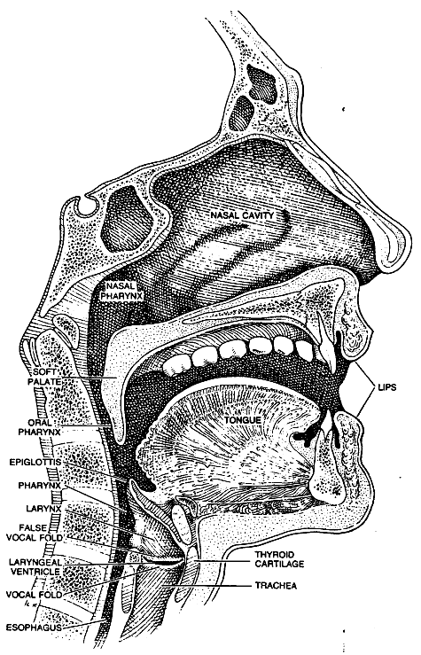
Worksheet: Model of human speech production
Figure 1. Voice organ

The voice organ is an “instrument” consisting of:
- a power supply (the lungs),
- an oscillator (the vocal folds), and
- a resonator (the vocal track).

The main function of lungs is to produce an excess of air pressure, thereby generating air stream. The air passes through the larynx, producing a vibration of the vocal folds (which are often called vocal cords). The frequency of the vibration is determined by the air pressure in the lungs and by the tension in the muscles that control the vocal folds (high tension makes the frequency and therefore the pitch high) and by the mass of the tissue (males usually have larger folds and therefore deeper voices).

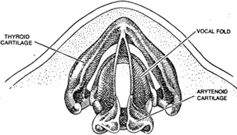
The vocal folds vibration releases pulses of air which produce a rapidly oscillation air pressure in the vocal track (the larynx, the pharynx and the mouth together), in other words sound. It is complex tone composed of a fundamental frequency (determined by the vibratory frequency of the vocal folds) and a large number of higher harmonics.
Figure 2. The vocal folds.

The vocal track is a resonant chamber which acoustics is determined by the shape of the vocal track, positions of the articulators: the lips, the jaw, the tongue and the larynx. For a certain shape of the vocal track, only certain resonant frequencies are amplified and other frequencies are suppressed. These frequencies are called formants (graph b).

The simplest model of the vocal tract would be to picture it as a single cylindrical tube with one closed end, at the glottis, and one open end, at the mouth. Such a tube can support standing waves. In such model, the formant frequencies correspond to the standing wave frequencies in the tube. Below the first four formants are shown as standing waves in cylindrical tubes together with the schematic equivalent of the vocal track.

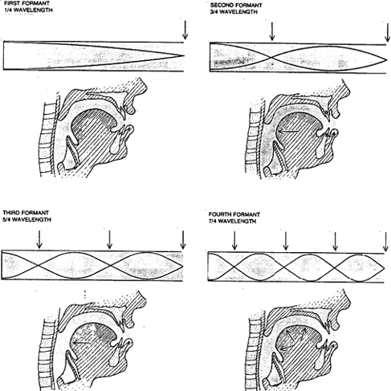

Formant frequencies manifest themselves in the spectrum of sound signal projected at mouth as peaks in the envelope, and those peaks are characteristics of particular vowel sound.

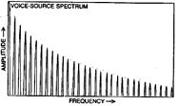
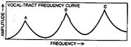
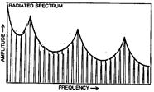

a) frequency spectrum of the voice

b) resonance frequencies of the vocal track – formants (A,B,C)

c) the final sound signal projected at the mouth (vowel spectrum).

In an adult male, the vocal folds are usually 17-23 mm long, and 12.5 -17 mm in an adult female. They may be stretched 3 or 4 mm by action of the muscles in the larynx. The male speaking voice averages about 125 Hz, while the female voice averages about 210 Hz. Children's voices average over 300 Hz.

