Worksheet: Sound signal analysis

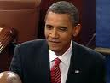
Why do we immediately recognize president Obama speaking, even without seeing him? Apparently, the sounds produced by his speech are characteristic enough to be able to do that. Just from a voice over the telephone, we are indeed able to infer all kinds of information like gender, age, level of education, dialects, mood and so on. What does science have to say about this commonly known fact?
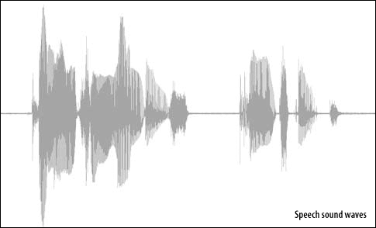
What is a “speech print” and is it indeed as unique as DNA or fingerprints?

Human speech analysis dates back to the mid twentieth century and has been an active field of research ever since. Governments (military, police -forensic phonetics-, psychology, espionage) eagerly made and make use of it. Recently, commercial applications come into play as well, with the development of passive and active speech computers, robotics, automation and security.

This is an open investigation. Formulate a research question connected to sound signal analysis, which you would like to investigate. Perform your investigation to answer your research question. Prepare a presentation about the results of your investigation for your classmates.

