Worksheet: Sound signal synthesis
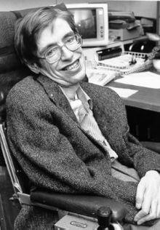
Stephen Hawkins is one of the most famous people using speech synthesis to communicate.
“… Scientists have attempted to simulate human speech since the late 1700s, when Wolfgang von Kempelen built a “Speaking Machine”, that used an elaborate series of bellows, reeds, whistles and resonant chambers to produce rudimentary words. By the 1970s digital computing enables the first generation of modern text-to-speech systems to reach fairly wide use. Makers of these systems attempted to model the entire speech production process directly, using a relatively small number of parameters. The result was intelligible, though somewhat robotic-sounding, speech. The advent of faster computers and inexpensive data storage in the late 1990s made today’s most advanced synthetic speech possible …”
(“Making Computer Talk”, by A. Aaron, E. Eide, J. Pitrelli, Scientific American, March 2003).

This is an open investigation. Formulate a research question connected to sound signal synthesis, which you would like to investigate. Perform your investigation to answer your research question. Prepare a presentation about the results of your investigation for your classmates.

