Worksheet: Fitness Training

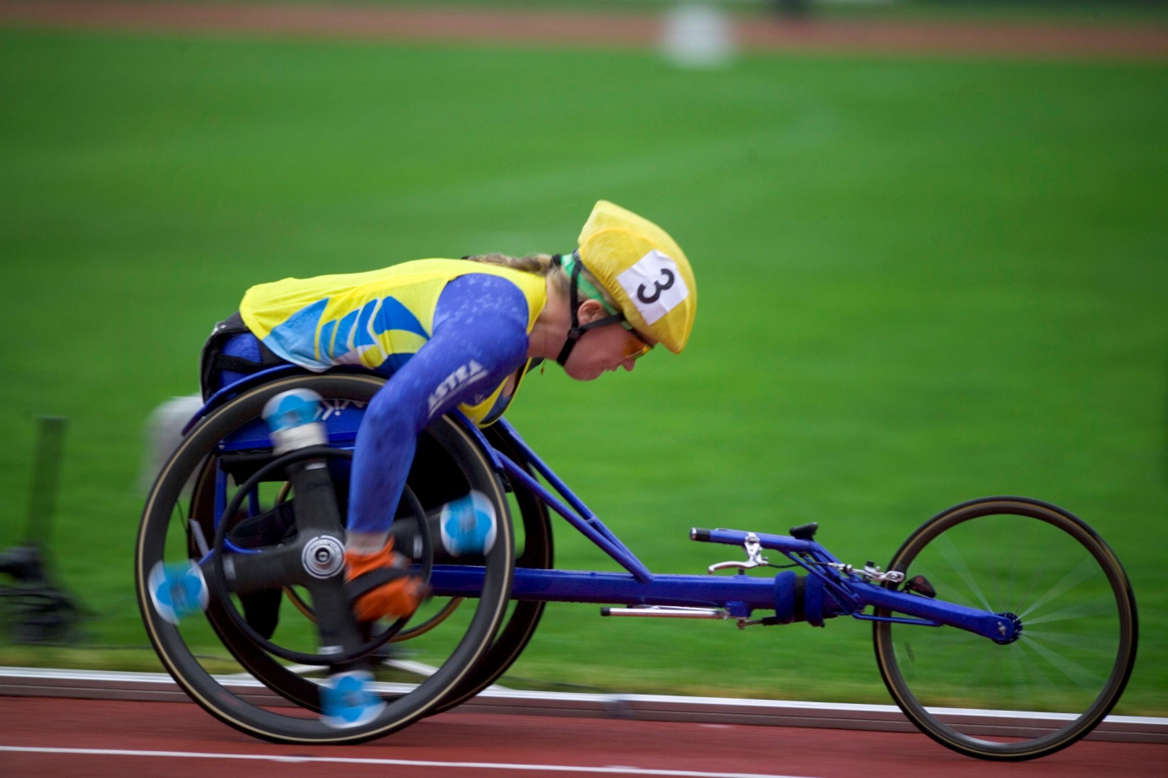
Photo:Scanpix

The woman in the picture seems to be very fit. It is obvious that she could not acquire such a good level of fitness by running, which otherwise is a common way to train. What sort of exercise can she do instead to increase her fitness?

- Write a hypothesis
- Plan an experiment
- What is it you are going to measure?
- How will you measure it?
- Report your results in a way that is easily understood.
- Evaluate your results: did you get different results using different methods of measuring? Using different groups? Any other differences?
- What conclusions can you draw?

