Worksheet: Disability Aids

This activity is for group work. The activity consists of three parts:
The first part is about disability aids
The second is about opening an ordinary package
The third part is about explaining the physical principles behind these things.

1. Begin by looking at and testing the objects lying on the table.
They might be the objects shown in the pictures. What do you think they are? What are these objects used for? What functions do they have? Explain how they move.

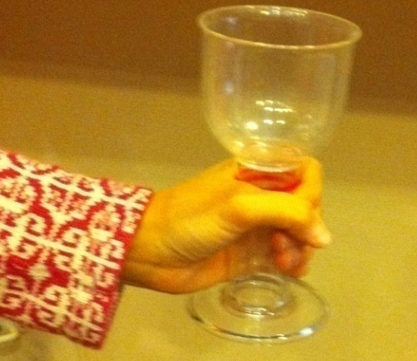 | 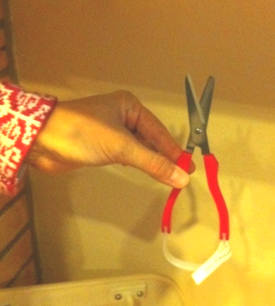 | 
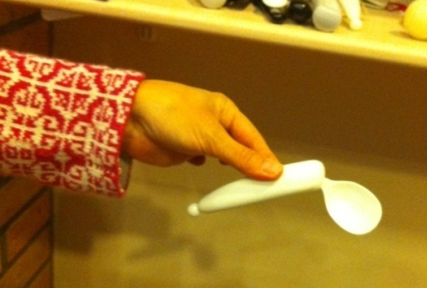 | 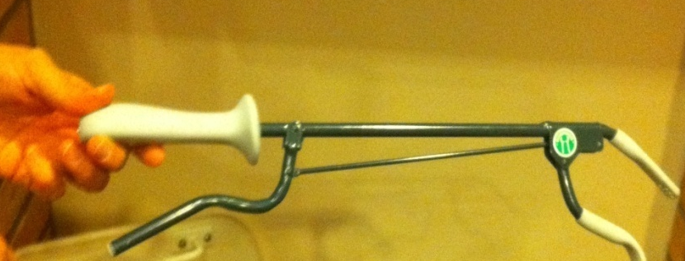

2. Imagine that you have weak muscles in your hands and try to open the packages with the help of one or other of these objects!

 |  |  |  |  | 

3. Explain and demonstrate the physical principles of the aids you have used.

