Worksheet: A visit to a disability aid centre

You are going to visit a disability aid centre.

Start by planning the visit. In your group, discuss:
- What aids do you think you will be able to see and test?
- What people do you think work there?
- What work do you think they do?
- How can you get more information? Do a search on the internet or talk to someone who knows about this.
- What questions should you ask on this visit?

Report on your visit using text and pictures, or with a film sequence.  Suggested content:  Which aids did I try, and how do they help the patients?  What new things did I learn?  I would like to know more about ... | 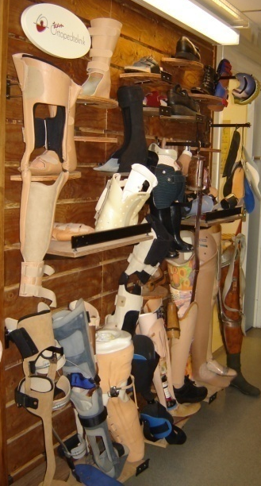 | 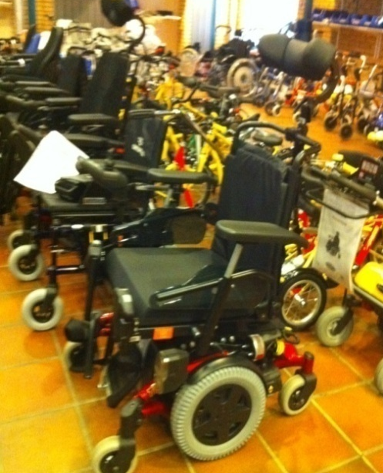
 | 