Worksheet: How do muscles work?

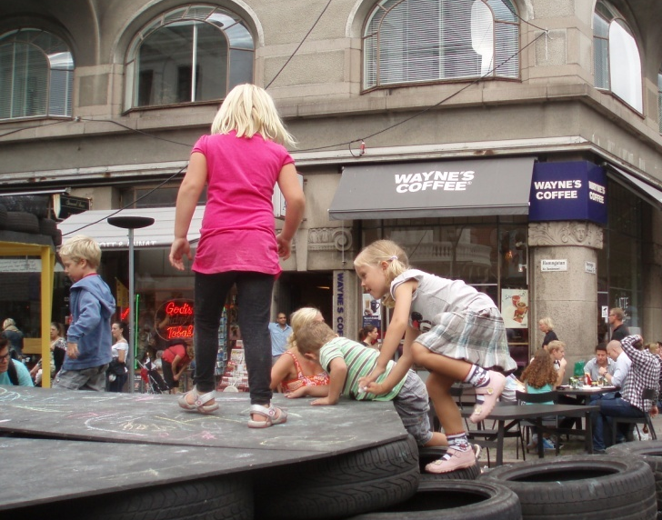 | 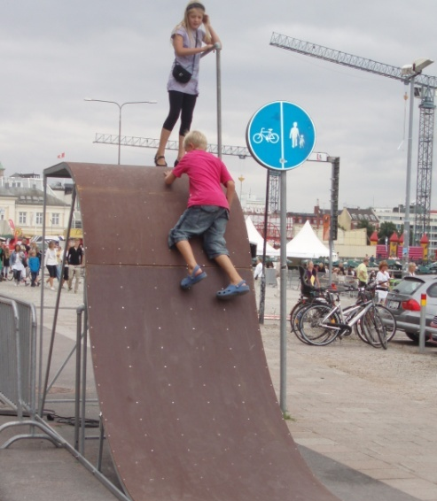

- Feel the way your muscles work.
Move different parts of your body and feel which muscles are working. Some suggestions:
  - Lift your leg straight up, and then lower it down again!
  - Bend your arm, and stretch it straight!
  - Wiggle your fingers!
  - Put one hand underneath a tabletop and pull upwards. With your other hand, feel your upper arm. Try to lift the table. In what part of the arm are the muscles working hardest?

- Which movements?
Look at the picture of the human muscles and pick some of the larger muscles such as the deltoid muscle, the back or stomach muscles, the thigh or calf muscles. Think about which movements occur when the muscles you chose are working. Test if your hypotheses are correct.

- Stretching

Which stretching exercises do you know? Try some of these and feel which muscles are being stretched in the different exercises.

Note down your observations.

Think about the results of these three tasks and summarize what you have learned about how muscles work.

