Worksheet: The strength and function of muscles

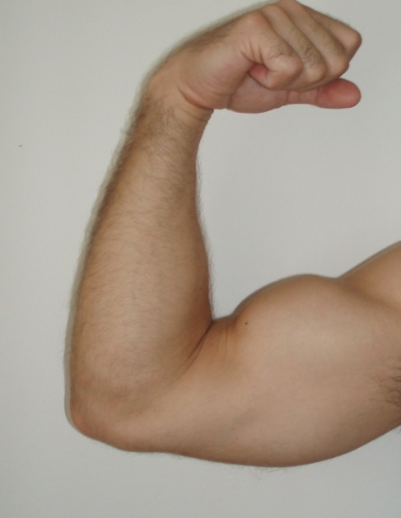 | The picture shows Magnus’ upper arm. His upper arm muscles are quite big because he is physically fit.  You will see below are three drawings of the muscles of the upper arm, the biceps, which are connected to the skeleton in various ways.  Discuss the strength and function in each of the drawings.  Can the muscle work in all three pictures?  If not, why not?

Use a dynamometer or a spring to test the three models, in the same way as in the pictures below. Which model shows the muscle working most effectively?

A | B | C

