Worksheet: Why do we breathe?

Anna Victor, Oscar and James are doing their homework and are discussing why we breathe.

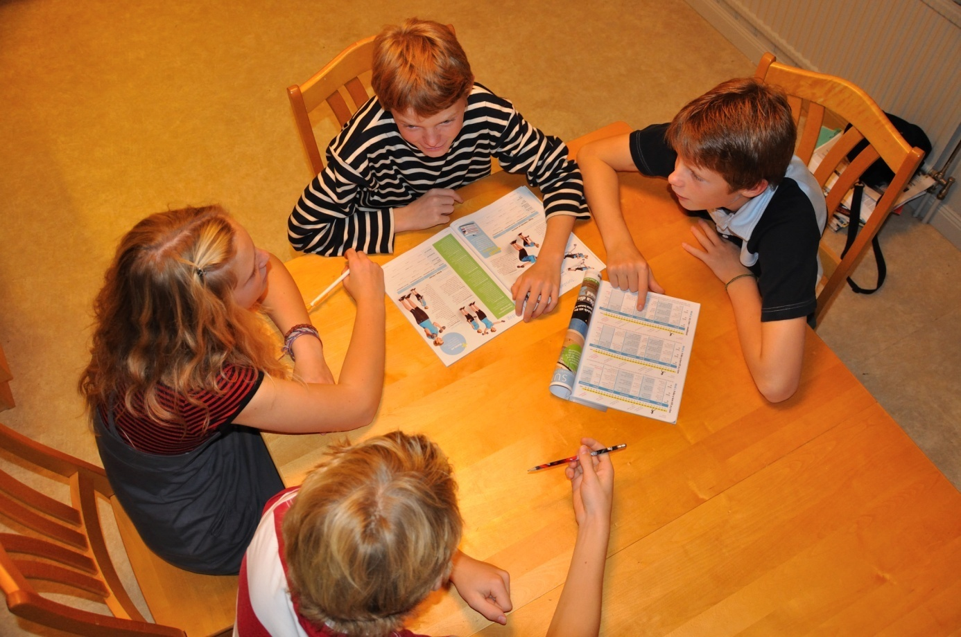
Have you thought about why we breathe?
Your lungs need oxygen!
If you don’t breathe, you die.
But so do your toes!

What do you think? Help these pupils to give a better explanation about why we have to breathe.

