Activity 11
A visit to a dialysis centre
We have planned an excursion to a dialysis centre.
Write questions that you will have to ask the medical staff to be able to describe the content of the following pictures in a form of coherent scientific text.

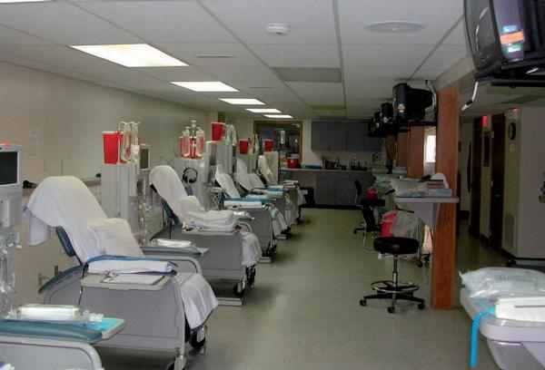
Source: http://www.zdn.cz/denni-zpravy/z-domova/dialyzacni-strediska-varovala-ze-nebudou-mit-dost-penez-na-lecbu-462604
Dialysis centre
Your questions:.....................................................................................................................
..............................................................................................................................................?
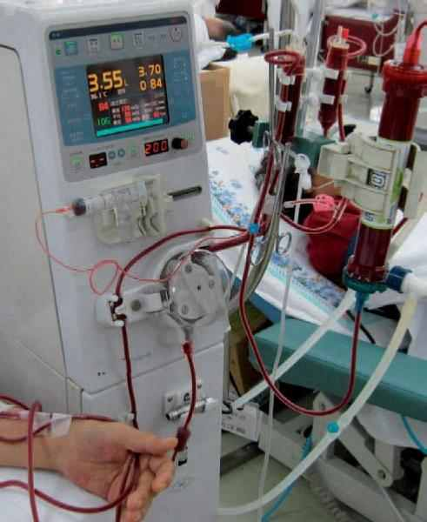
Source: http://www.zdn.cz/clanek/zdravotnicke-noviny/zit-bez-ledvin-bude-tezsi-kvuli-skrtum-462669?category=z-domova
Hemodialyser
Your questions:.....................................................................................................................
..............................................................................................................................................?
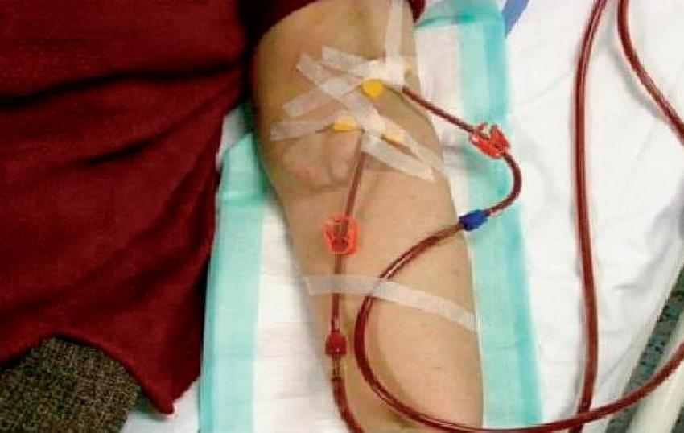
Source: http://www.zdn.cz/clanek/sestra/cevni-pristupy-u-dialyzovanych-pacientu-462309
Arteriovenous fistula
Your questions:.....................................................................................................................
..............................................................................................................................................?

Write more questions that you are interested in as for the given issue, and that you would like to ask the medical staff or the patients.
Your questions:
................................................................................................................................................
..............................................................................................................................................................................................................................................................................................................................................................................................................................................................................................................................................................................................?

